

CAPSTONE PROJECT REPORT
Report 3 – Software Requirement Specification

– Ho Chi Minh, October 2026 –

Table of Contents

Table of Contents 2
I. Record of Changes 4
II. Software Requirement Specification 6
1. Product Overview 6
1.1 Product Scope6
1.2 System Context 7
2. User Requirements 8
2.1 Actors 8
2.2 Use Cases 8
2.2.1 Diagram(s) 8
2.2.2 Descriptions 12
3. Functional Requirements 14
3.1 System Functional Overview 14
3.1.1 Screens Flow 14
3.1.2 Screen Descriptions 14
3.1.3 Screen Authorization 15
3.1.4 Non-Screen Functions 16
3.1.5 Entity Relationship Diagram 16
3.1.6 Mainflow Activity Diagrams 18
3.1.7 Lifecycle Diagrams 22
3.2 FE-01 — UAV and Operator Management 24
3.2.1 Sign in and sign out (UC-01) 24
3.2.2 Manage UAV records (UC-02) 24
3.2.3 Manage operators and assignments (UC-03) 25
3.2.4 Configure operational restrictions (UC-04) 26
3.3 FE-02 — Mission Planning and Management 27
3.3.1 Create a mission plan (UC-05) 27
Screen layout — SCR-0728
3.3.2 Edit a route and request mission updates (UC-06) 28
3.3.3 View or cancel a mission plan (UC-07) 29
3.4 FE-03 — Mission Approval Workflow 30
3.4.1 Submit a mission for validation (UC-08) 30
3.4.2 Approve or reject a mission (UC-09) 31
3.4.3 Review approval history (UC-10) 32
3.5 FE-04 — Geofence and Flight Path Validation 32
3.5.1 Validate waypoints and route segments (UC-11) 32
3.5.2 Review mapped validation results (UC-12) 32
3.6 FE-05 — MAVLink Telemetry Integration 33
3.6.1 Provide and ingest telemetry (UC-13) 33
3.7 FE-06 — Real-Time Mission Monitoring 33
3.7.1 Monitor an active mission (UC-14) 33
3.8 FE-07 — Operational Alert and Incident Detection 34
3.8.1 Detect incidents and deliver alerts (UC-15) 34
Screen layout — SCR-1135
3.9 FE-08 — Incident Management and Post-Flight Analysis 35
3.9.1 Review and manage an incident (UC-16) 35
3.9.2 Finalize a flight and generate a post-flight report (UC-17) 36
3.9.3 Review mission history and post-flight results (UC-18) 37
3.10 FE-09 — AI-Assisted Mission Decision Support 38
3.10.1 Request an AI-assisted risk assessment (UC-19) 38
3.10.2 Review AI advice and supplied context (UC-20) 39
3.11 FE-10 — Mission and Operational Dashboard 40
3.11.1 View an operational dashboard (UC-21) 40
3.11.2 Review operational analytics (UC-22) 41
4. Non-Functional Requirements 43
4.1 External Interfaces 43
4.2 Quality Attributes 43
4.2.1 Usability 44
4.2.2 Reliability 44
4.2.3 Performance 44
4.2.4 Security and Privacy 45
4.2.5 Maintainability and Testability 45
4.2.6 Compatibility and Recovery 45
5. Requirement Appendix 46
5.1 Business Rules 46
5.2 Common Requirements 46
5.3 Application Messages List 47
5.4 Requirements Traceability48
Review 2 baseline notes and requirement clarification 51

I. Record of Changes
Date | A*  M, D | In charge | Change Description
14/09/26 | A | ThongLQ | Added AI-assisted assessment, context and workflow diagrams, and detailed functional requirements.
16/09/26 | M | Project team | Updated ownership of the four mainflows: NghiaHQ — MF1; KhanhGNG — MF2; DucDDA — MF3; ThongLQ — MF4.
19 October 2026 | M | NghiaHQ | Revised mission planning to use one current mission and reviewed update requests; retained validation and decision evidence.
20 October 2026 | M | Project team | Completed functional requirements, lifecycle and authorization rules, pilot account/license workflows, telemetry/report policies and historical similarity evidence; corrected incomplete wording and traceability.

A = Added; M = Modified; D = Deleted.

II. Software Requirement Specification

1. Product Overview
DroneOps Intelligence manages UAVs, pilot accounts and flight credentials, mission planning and reviewed updates, configured flight restrictions, live telemetry, incidents, post-flight evidence and historical-mission-based decision support. The Web application supports Operators and Operations Managers. The Operator mobile client covers account/profile access, own/assigned mission viewing, validation and decision results, live monitoring, alerts and history; mission route editing and Manager administration are Web functions.
The platform validates routes against configured restrictions before Manager approval. A MAVLink-compatible UAV/autopilot or simulator supplies telemetry through an integration gateway. The platform detects configured abnormal conditions, retains evidence and generates post-flight reports. AI decision support retrieves similar historical flights and their incident evidence; a configured OpenAI or Gemini service may summarize that evidence. AI advice never replaces mandatory validation or Manager decisions.
Scope exclusions: no low-level navigation, stabilization, autonomous flight execution or replacement of GCS/autopilot software. Custom model training and autonomous AI approval are outside scope. Restriction checks cover configured data only; they do not certify compliance with unprovided restrictions.
Flow | Purpose | Primary owner | Features
MF1 | Mission Planning & Pre-flight Validation | NghiaHQ | FE-02/03/04
MF2 | Real-Time Monitoring & Incident Management | KhanhGNG | FE-05/06/07/08/10
MF3 | Post-Flight Analysis & Mission History | DucDDA | FE-08/10
MF4 | AI-Assisted Mission Risk Assessment | ThongLQ | FE-09/10

1.1 Product Scope
The system covers mission planning and approval, pre-flight validation, realtime monitoring, incident management, post-flight reporting and AI-assisted decision support. Operations are organized into four mainflows with shared UAV and operator management.

1.2 System Context
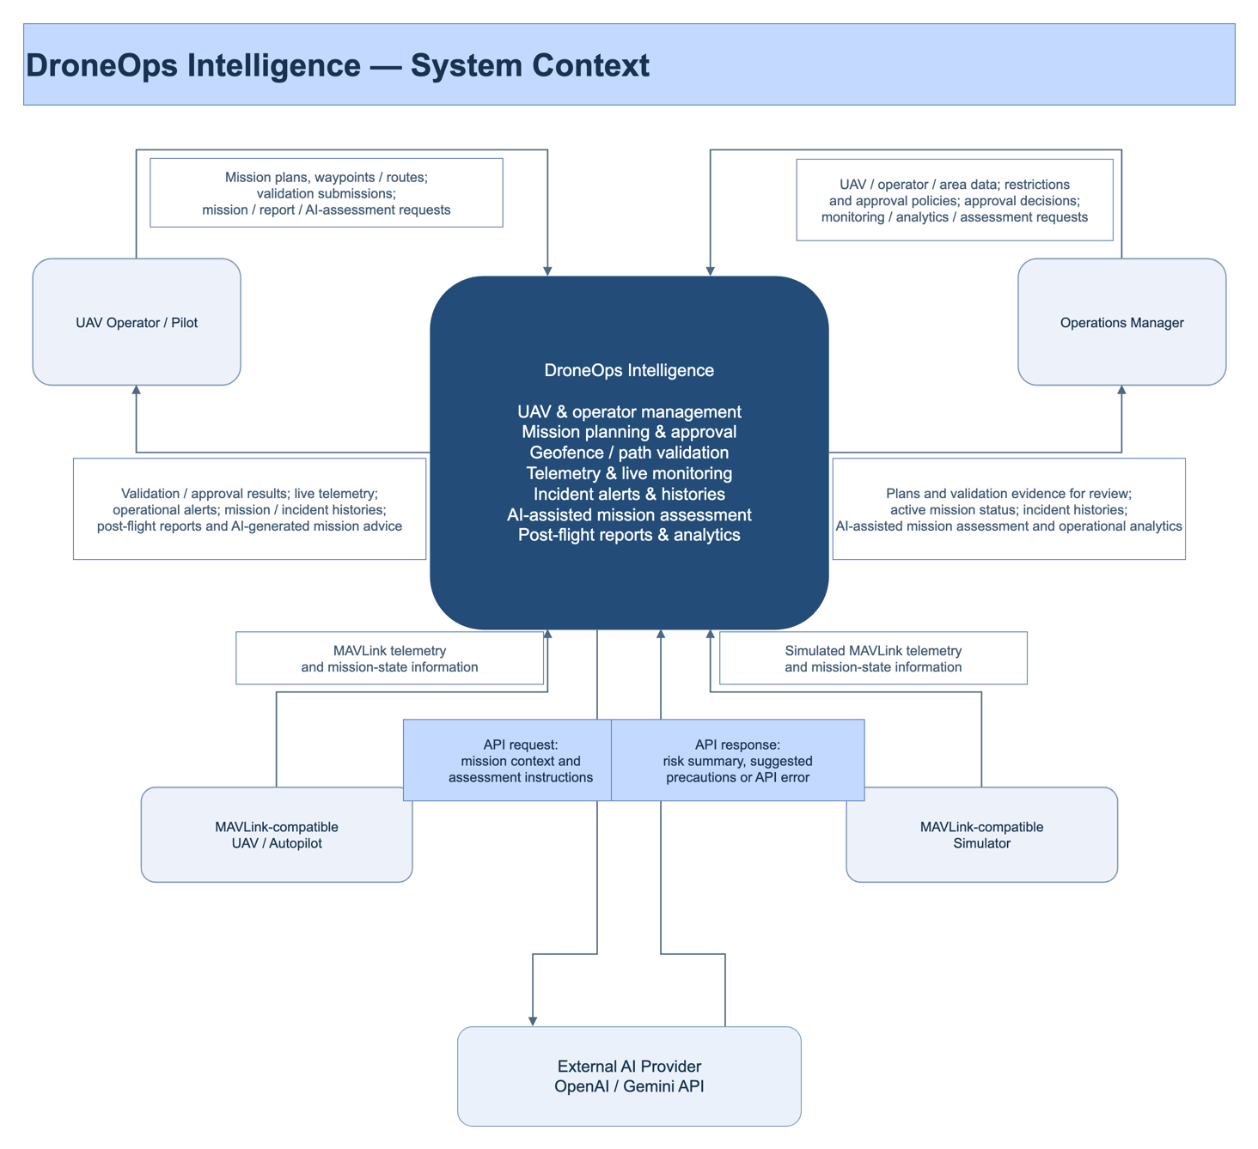
Figure 1. System context diagram.

2. User Requirements

2.1 Actors
ID | Actor | Responsibilities
ACT-01 | UAV Operator / Pilot | Create and submit own/assigned missions; review validation, decisions, live telemetry, alerts, history and AI evidence; manage own profile and credentials. Operator Web/mobile scope follows IF-02.
ACT-02 | Operations Manager | Manage UAV/operator/area data and restrictions; review and approve/reject missions; monitor operations and review reports/AI advice.
ACT-03 | UAV/Autopilot or Simulator | Supply MAVLink telemetry and configured mission-state events. These are alternative compatible data sources; no human login is required.
ACT-04 | External AI Provider | Return advisory content or API errors for authorized backend requests to the configured OpenAI or Gemini service.
ACT-05 | Pilot Applicant | Register a pilot account, verify the proposed email and provide license evidence; operational access is granted only after Manager approval.

2.2 Use Cases

2.2.1 Diagram(s)
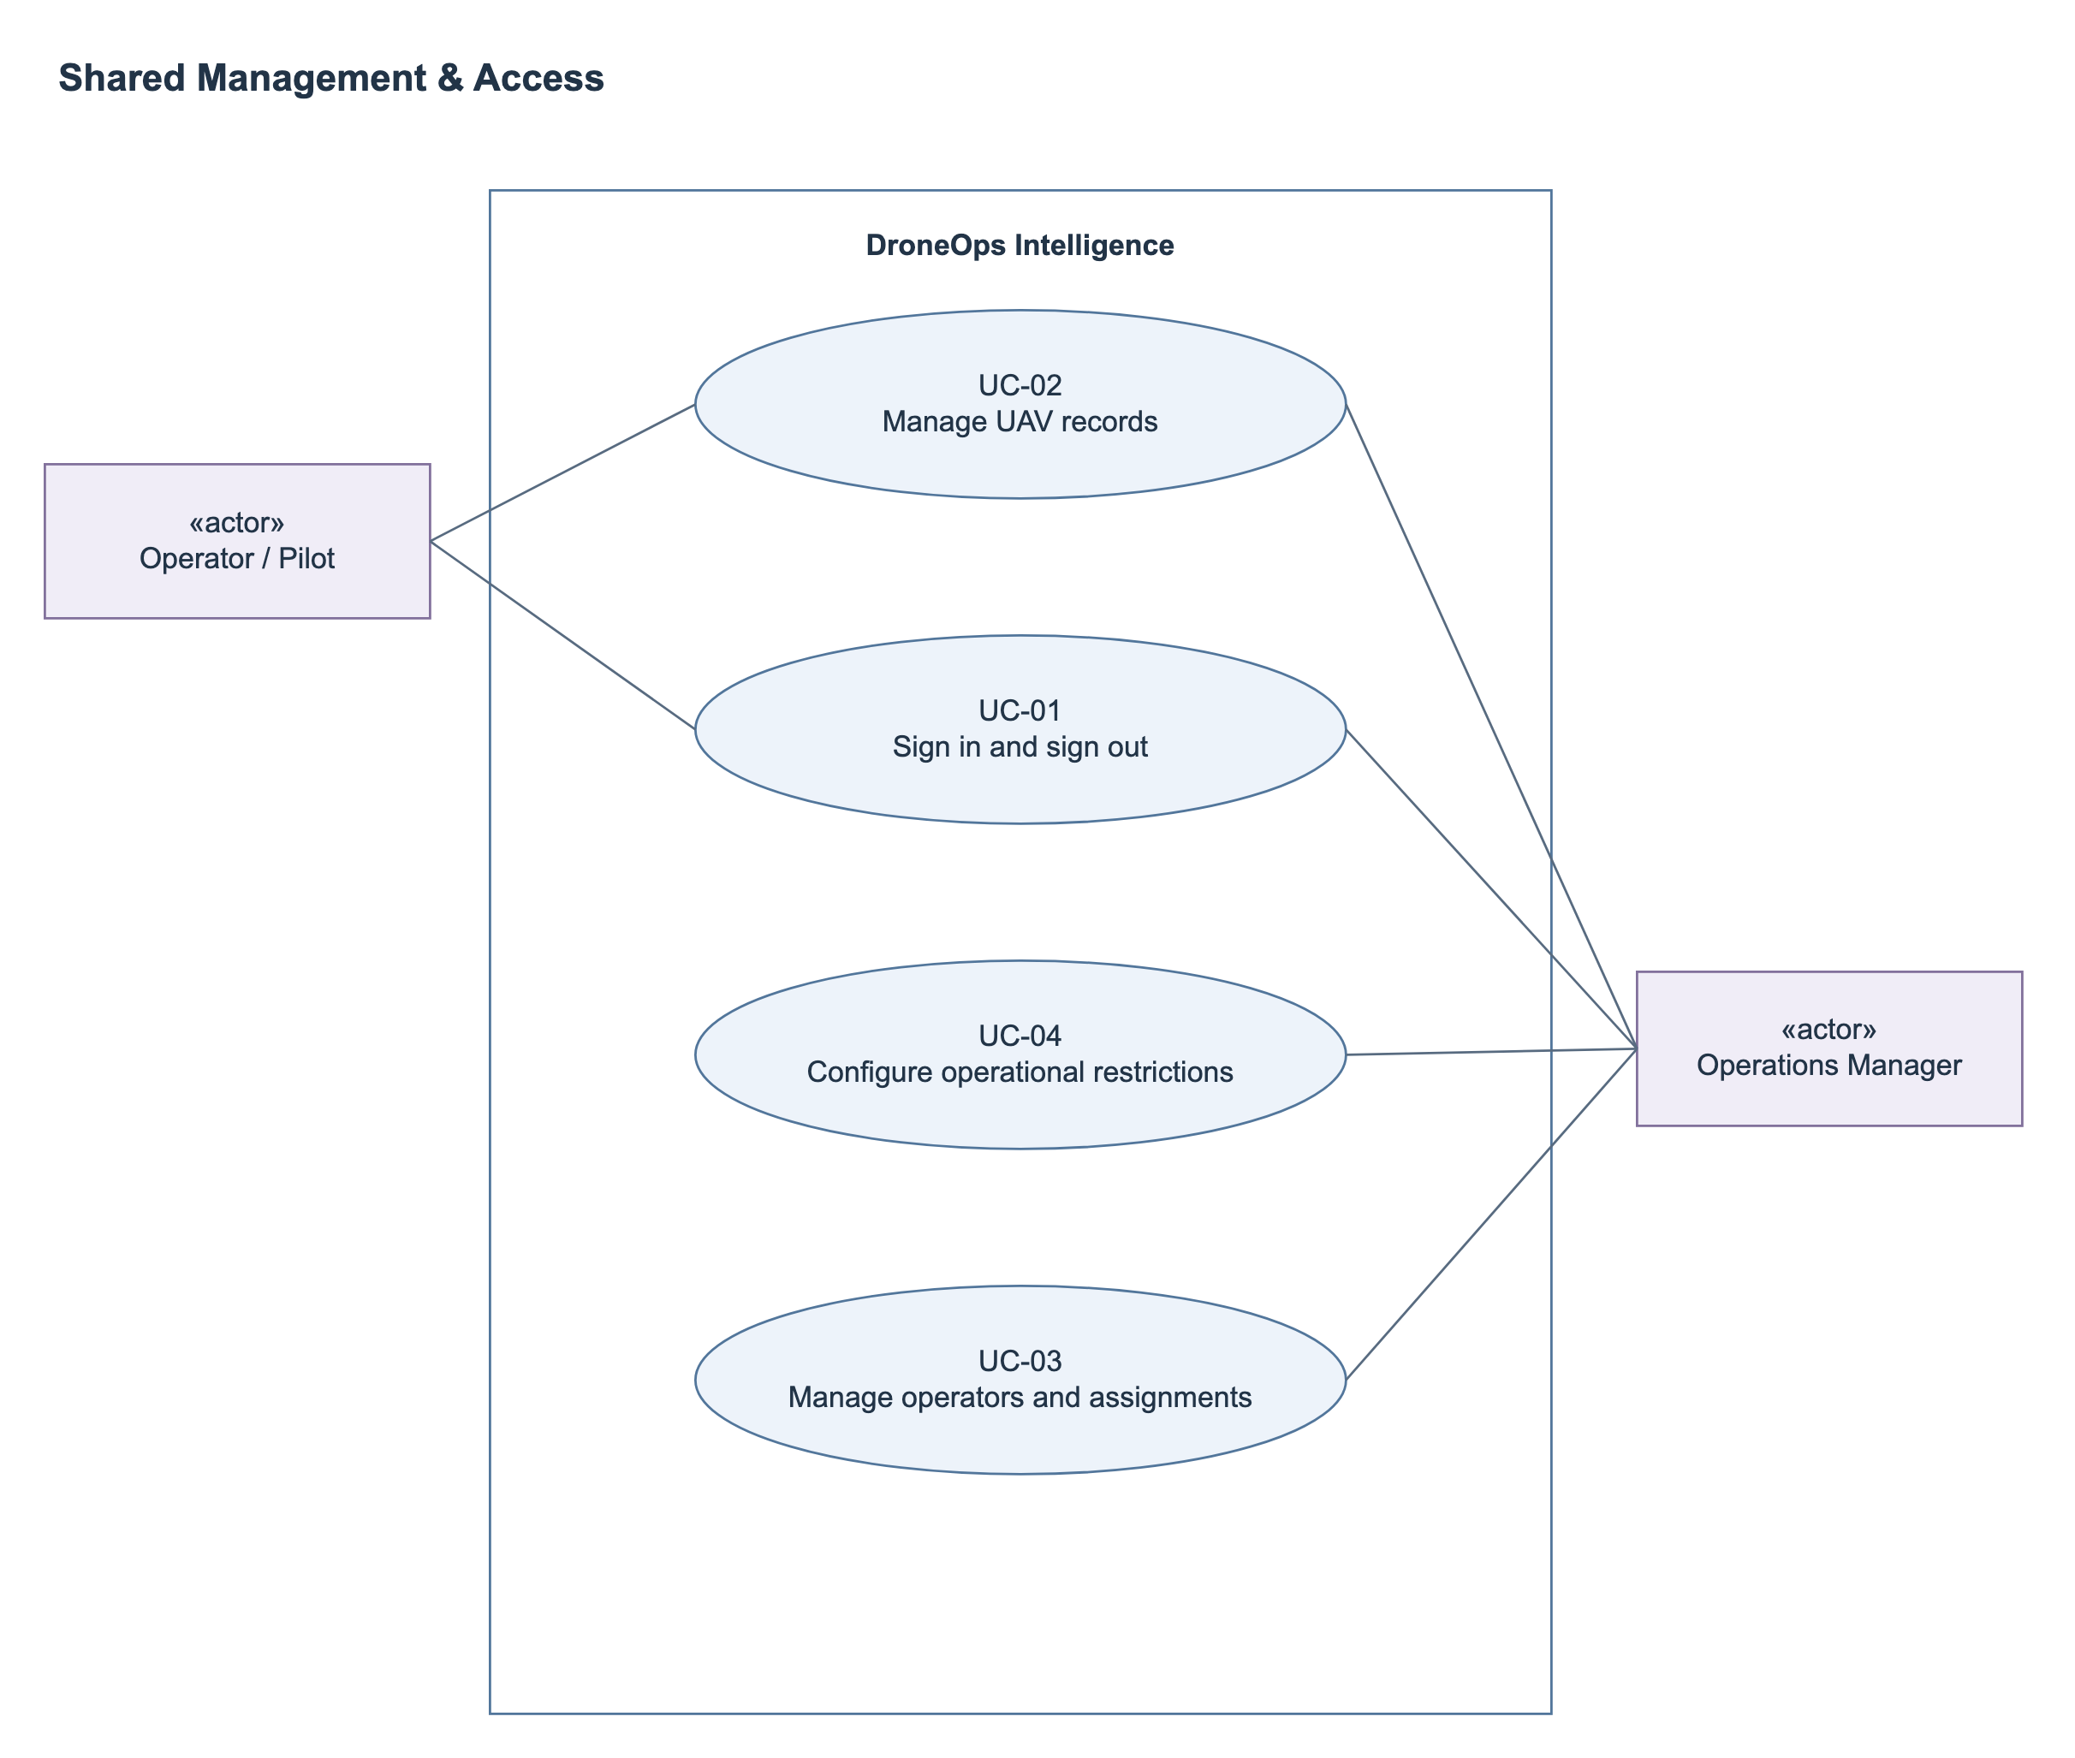
Figure 2. Shared Management & Access
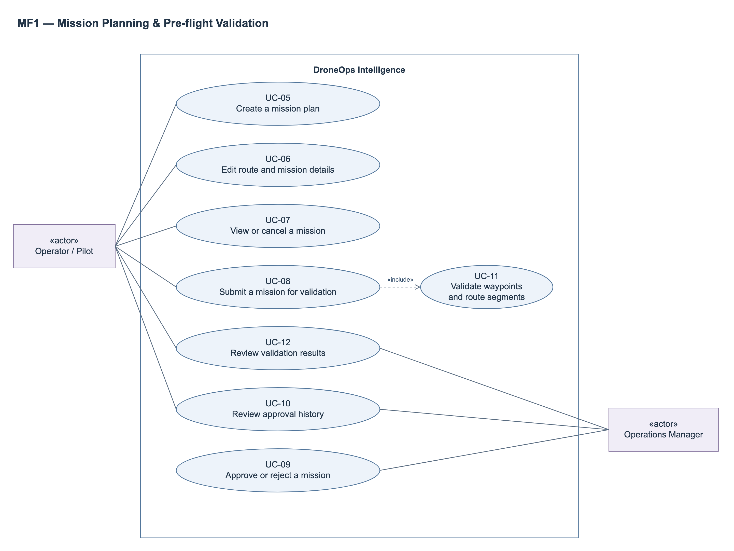
Figure 3. MF1 - Mission Planning & Pre-flight Validation
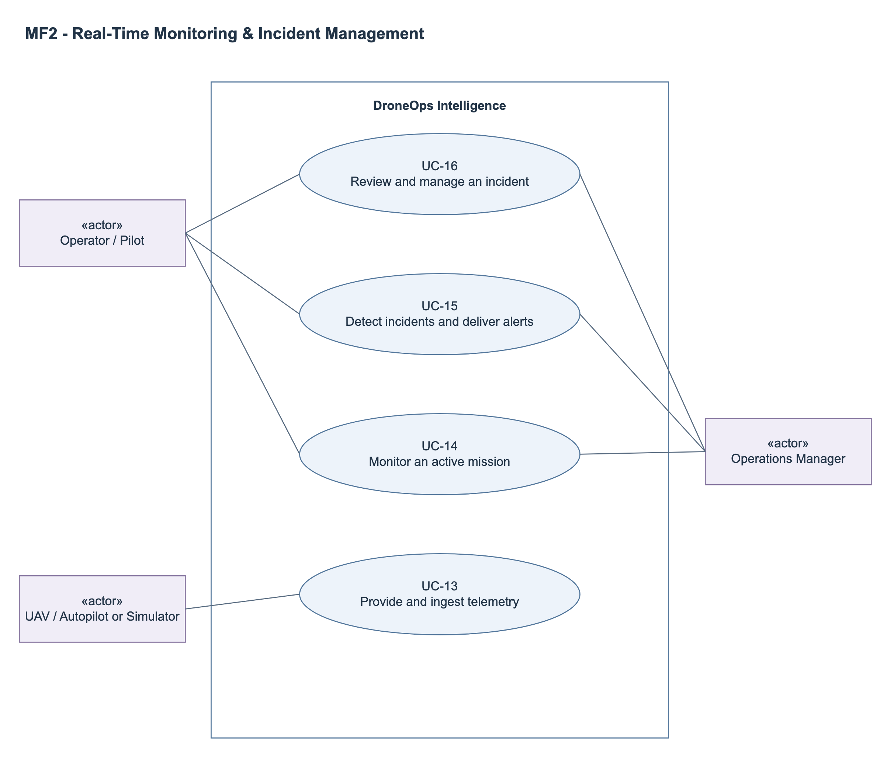
Figure 4. MF2 - Real-Time Monitoring & Incident Management
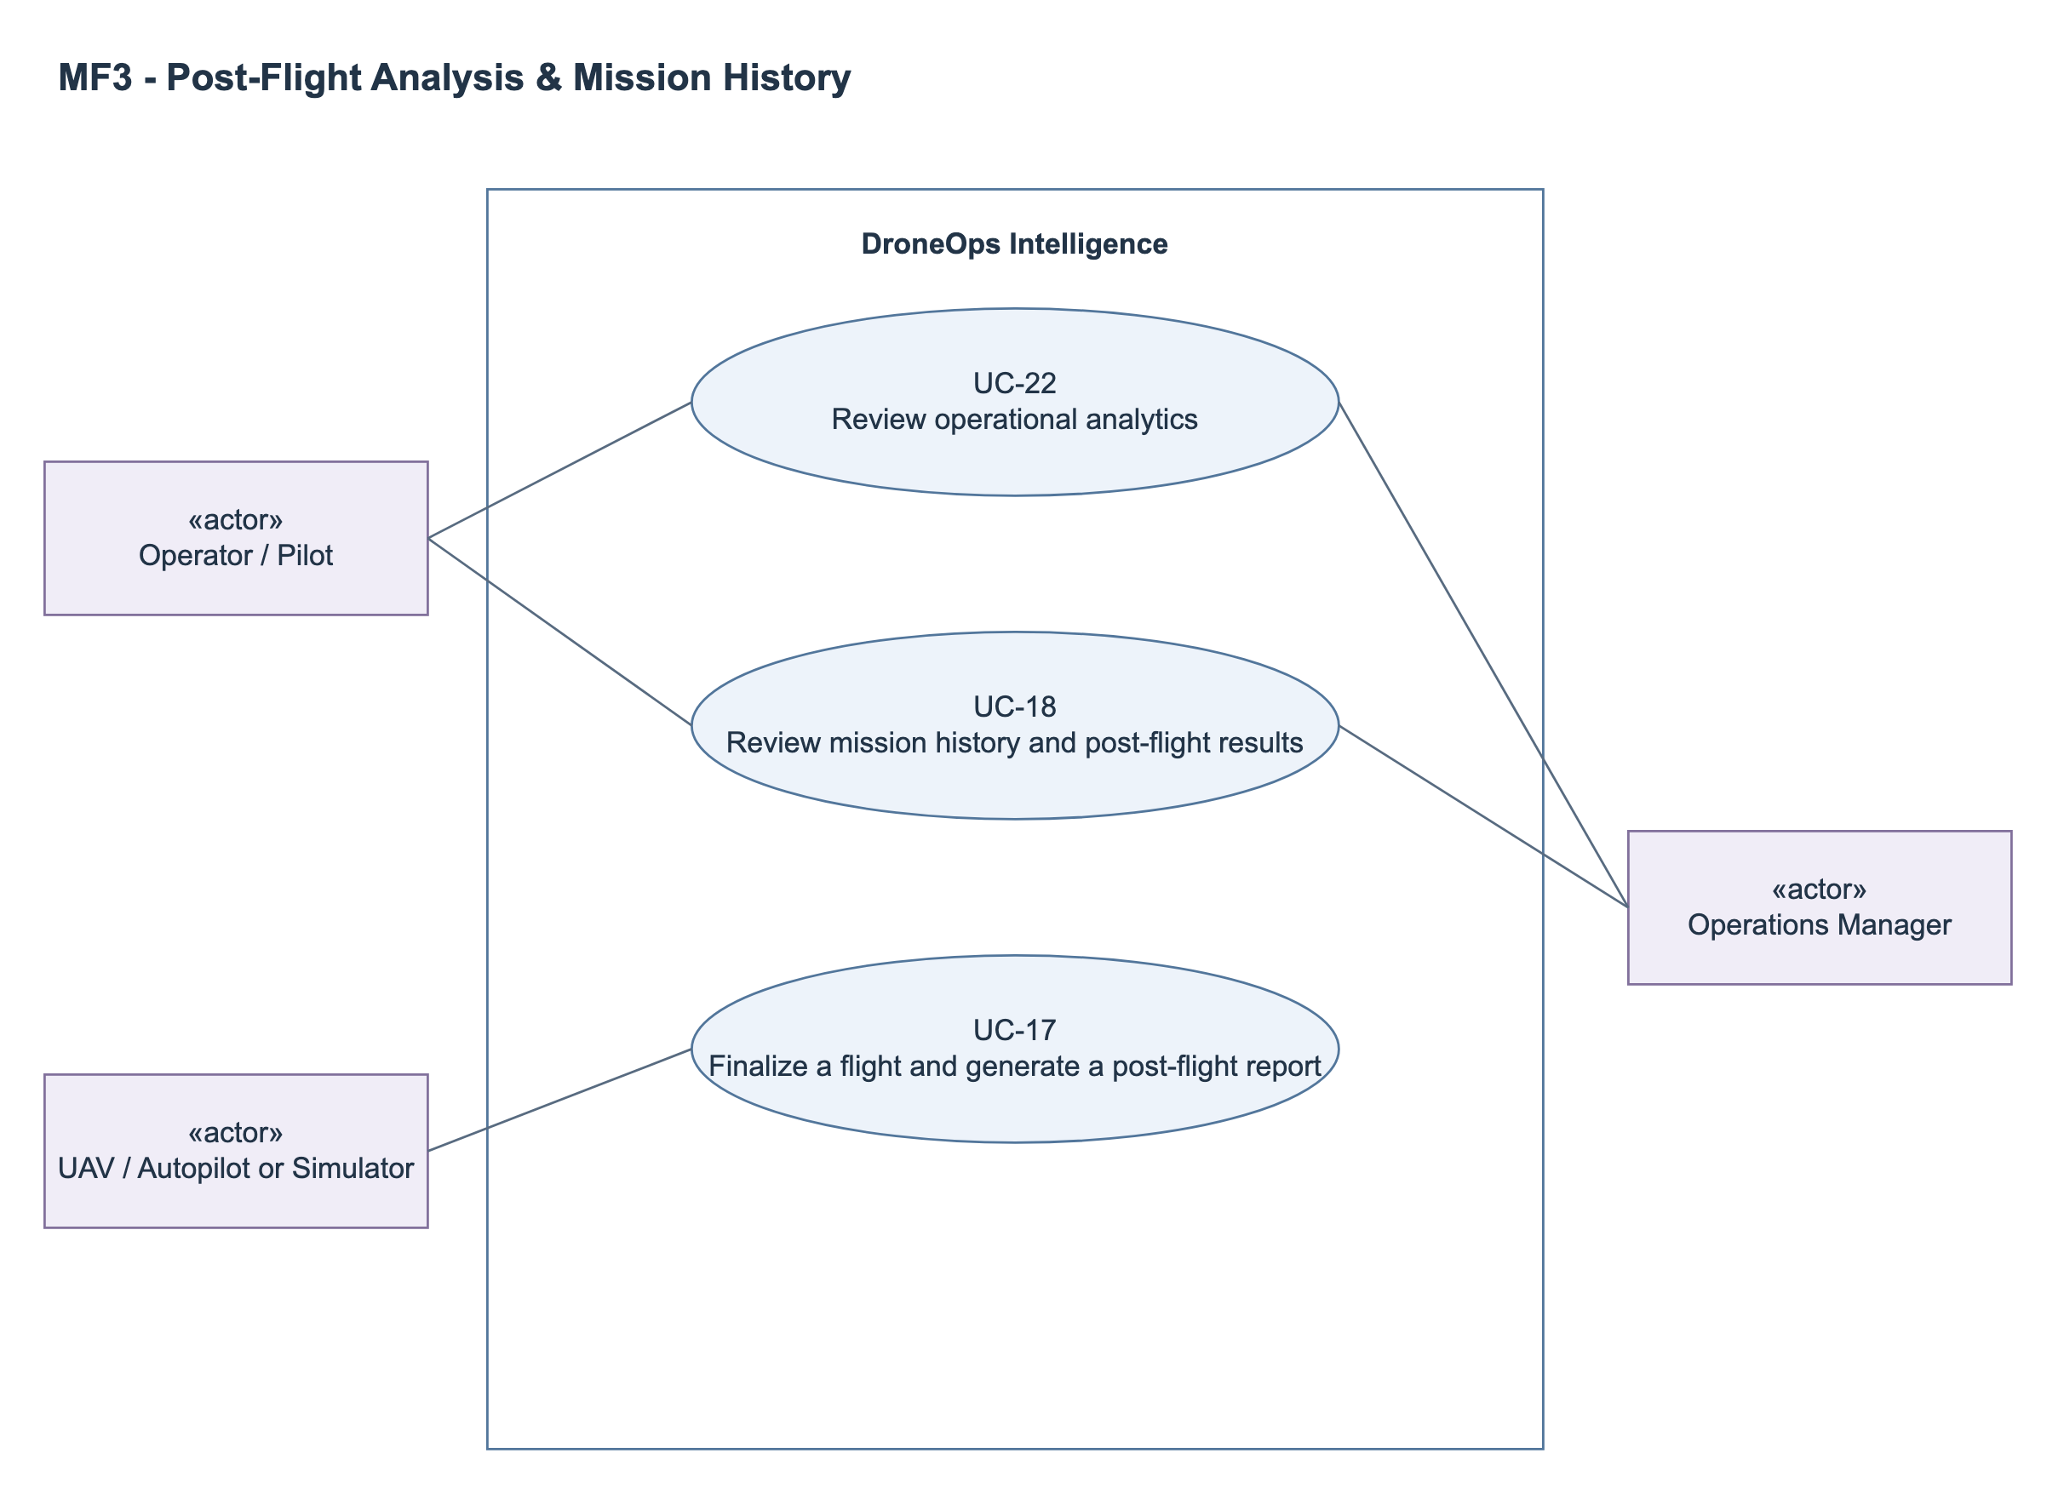
Figure 5. MF3 - Post-Flight Analysis & Mission History
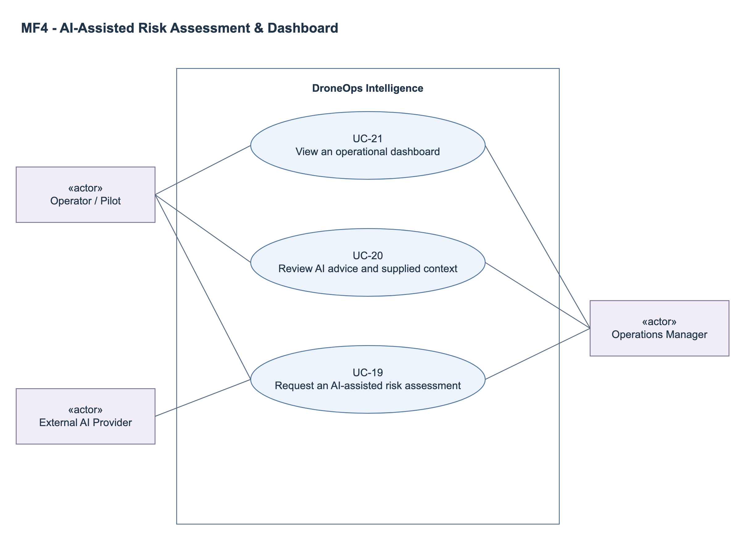
Figure 6. MF4 - AI-Assisted Risk Assessment & Dashboard

2.2.2 Descriptions
ID | Use Case | Actors | Outcome
UC-01 | Sign in and sign out | Operator; Manager | Authenticated role-scoped session or signed-out state.
UC-02 | Manage UAV records | Manager; Operator (view only) | Saved UAV record and recorded actor/time of change.
UC-03 | Manage operators and assignments | Manager | Updated operator/assignment records.
UC-04 | Configure operational restrictions | Manager | Versioned operational restrictions available to validation.
UC-05 | Create a mission plan | Operator | Draft mission owned by the creator.
UC-06 | Edit a route and request mission updates | Operator; Manager | A proposed update stored with author/time and sent to Manager review; current mission content is preserved until approval.
UC-07 | View or cancel a mission plan | Operator; Manager | Mission details shown or planning record cancelled with audit evidence.
UC-08 | Submit a mission for validation | Operator | Mission/update request visible for Manager review with validation outcome; failed, incomplete or stale checks block approval.
UC-09 | Approve or reject a mission | Manager | Immutable decision linked to mission and update request; approval applies proposed content, rejection preserves current content and any existing approval.
UC-10 | Review approval history | Operator; Manager | Traceable approval history.
UC-11 | Validate waypoints and route segments | Operator (via submission) | Mission/update-request-linked validation result and map evidence.
UC-12 | Review mapped validation results | Operator; Manager | User can locate violations and decide whether to edit/resubmit.
UC-13 | Provide and ingest telemetry | UAV/Autopilot or Simulator | Stored telemetry and updated UAV/mission projection without flight-control commands.
UC-14 | Monitor an active mission | Operator; Manager | Real-time operational view with explicit freshness.
UC-15 | Detect incidents and deliver alerts | UAV/Simulator (data source); Operator; Manager | Persisted incident and available in-app alert; no autonomous control action.
UC-16 | Review and manage an incident | Operator; Manager | Reviewed incident with append-only status history.
UC-17 | Finalize a flight and generate a post-flight report | UAV/Autopilot or Simulator (completion source) | Completed flight history and available or explicitly failed report.
UC-18 | Review mission history and post-flight results | Operator; Manager | User reviews recorded flight evidence and report.
UC-19 | Request an AI-assisted risk assessment | Operator; Manager | Available assessment or explicit failed status; no change to mission approval.
UC-20 | Review AI advice and supplied context | Operator; Manager | Human-reviewed advisory evidence, with manual mission review still available.
UC-21 | View an operational dashboard | Operator; Manager | Role-scoped operational overview.
UC-22 | Review operational analytics | Operator; Manager | Explainable aggregate view backed by recorded data.
UC-23 | Register a pilot account and review registration | Applicant; Manager | Verified registration and immutable review outcome; only approved pilots receive operational access.
UC-24 | Edit profile and avatar | Operator; Manager (own profile) | Saved profile fields and avatar with visible success/error feedback.
UC-25 | Change email with verification | Operator; Manager (own account) | Verified new account email or unchanged current email on any failure.
UC-26 | Request and review a license change | Operator; Manager reviewer | Approved replacement or unchanged current credentials with traceable pending/rejected outcome.

3. Functional Requirements

3.1 System Functional Overview
Feature IDs FE-01 to FE-10 preserve Report 1 traceability. UC IDs identify user/system interactions. Each detailed function defines FR-xx.1 (normal behavior), FR-xx.2 (validation and exceptional behavior), and FR-xx.3 (persisted/displayed outcome). Screens may support multiple features; internal processing is listed separately.

3.1.1 Screens Flow
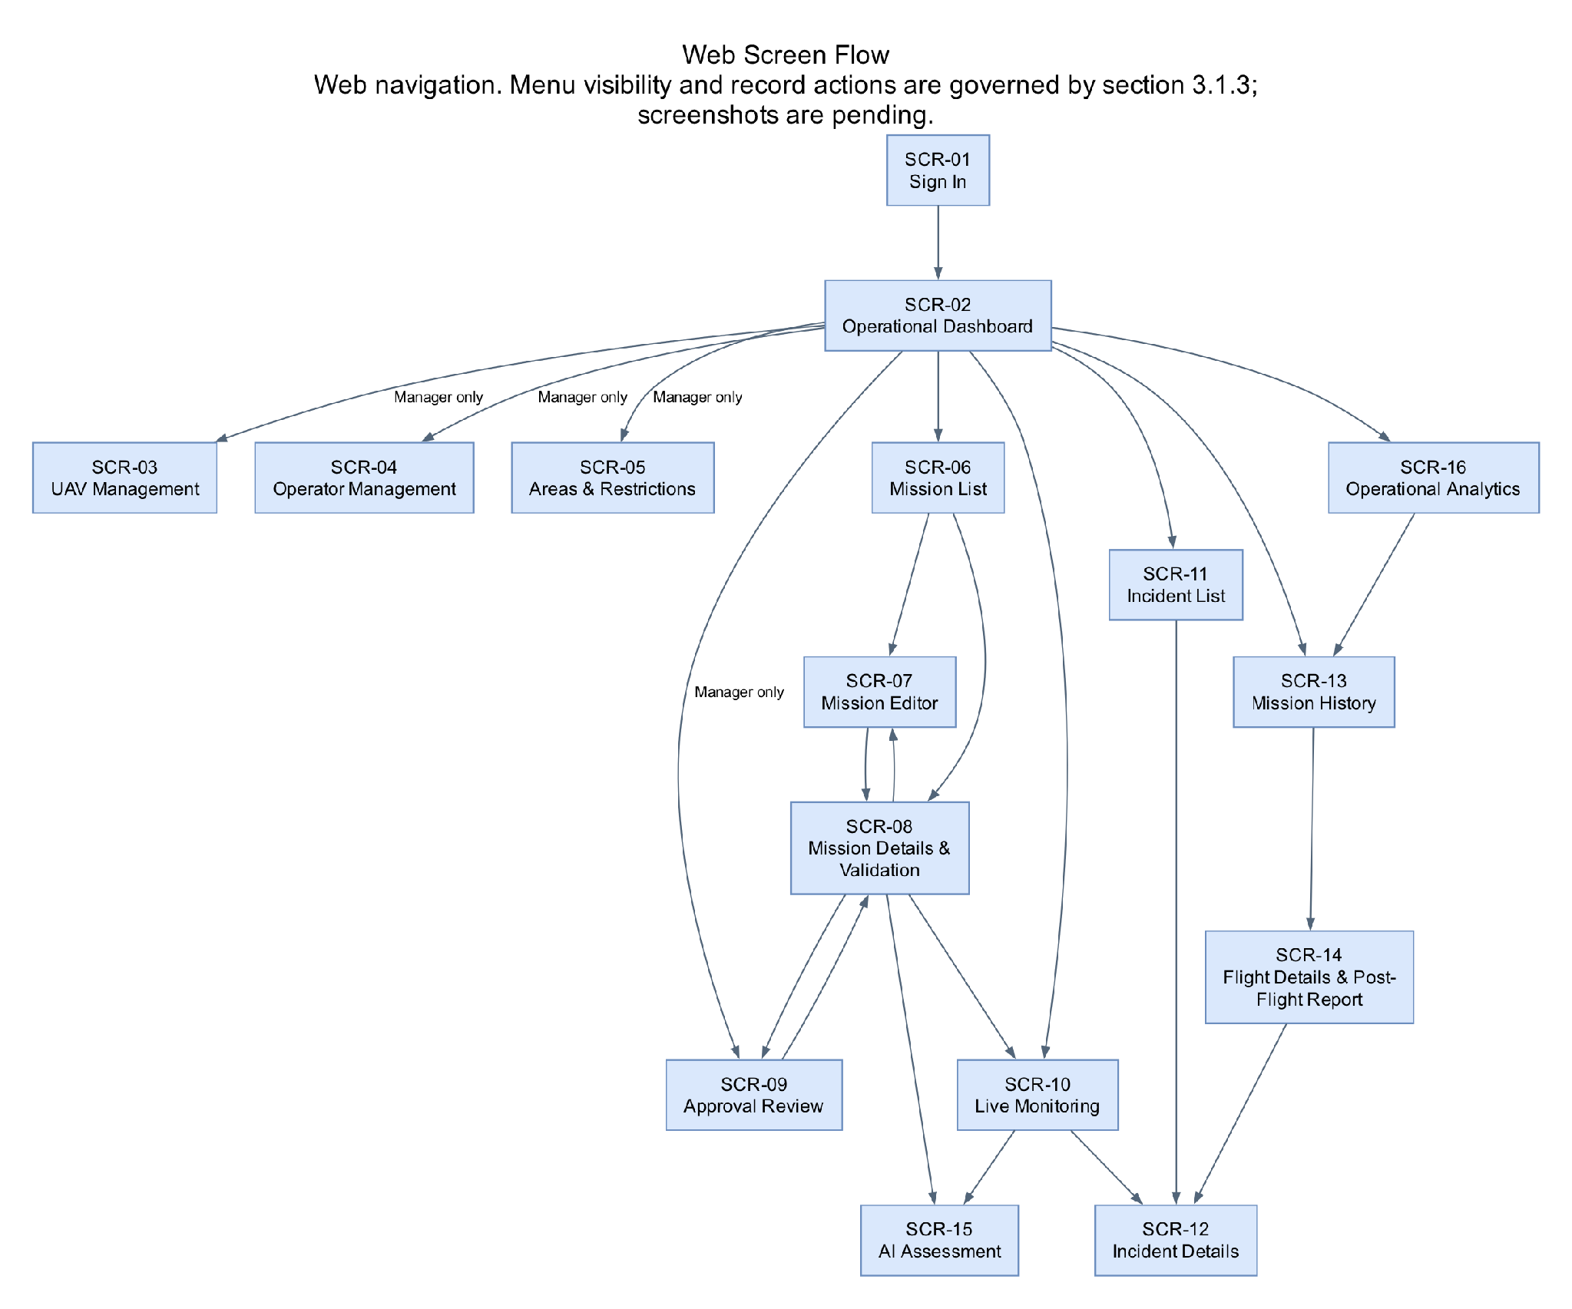
Figure 7. Web screen flow.

3.1.2 Screen Descriptions
ID | Feature | Screen | Description / Navigation
SCR-01 | FE-01 | Sign In | Login page before authentication. Form and invalid-credential message.
SCR-02 | FE-10 | Operational Dashboard | Dashboard. Summary cards, active missions, recent alerts and navigation.
SCR-03 | FE-01 | UAV Management | Management > UAVs. List plus Add/Edit UAV form.
SCR-04 | FE-01 | Operator Management | Management > Operators. Operator list, account status and assignment form.
SCR-05 | FE-01/04 | Areas & Restrictions | Management > Operational Areas & Restrictions. Map, polygon editor, restriction type and altitude fields.
SCR-06 | FE-02 | Mission List | Missions. Search/filter, status column and New Mission action.
SCR-07 | FE-02 | Mission Editor | Missions > New Mission or Details > Edit. Metadata, UAV/operator selection, ordered waypoint list and route map.
SCR-08 | FE-02/03/04 | Mission Details & Validation | Missions > select mission. Overview, current/proposed content and review decisions and validation map with failing segments.
SCR-09 | FE-03 | Approval Review | Approvals > pending mission. Submitted mission/update request, evidence, Approve/Reject and rejection-reason dialog.
SCR-10 | FE-05/06/07 | Live Monitoring | Live Monitoring > select mission. Live map, six telemetry indicators, timestamp/freshness, progress and alerts.
SCR-11 | FE-07/08 | Incident List | Incidents. Filters, type/severity/status and affected mission.
SCR-12 | FE-08 | Incident Details | Incidents > select incident. Event evidence, linked telemetry, history and acknowledgement/resolution controls.
SCR-13 | FE-08 | Mission History | Mission History. Completed flight list with date/UAV/status filters.
SCR-14 | FE-08 | Flight Details & Post-Flight Report | Mission History > select flight. Recorded route, telemetry summary, incidents and report status/content.
SCR-15 | FE-09 | AI Assessment | Mission Details or Live Monitoring > AI Assessment. Mission context, Generate/Retry, summary, risks, precautions and unavailable state.
SCR-16 | FE-10 | Operational Analytics | Dashboard > Analytics. Date/UAV filters, defined metrics/charts and links to histories.
SCR-17 | FE-01 | Pilot Registration | Public registration and email verification; application status and rejection feedback.
SCR-18 | FE-01 | My Profile | Phone, date of birth, brief flight experience and avatar; own account only.
SCR-19 | FE-01 | Change Email | New email, send/resend code, confirm and prominent outcome feedback.
SCR-20 | FE-01 | My Flight Credentials | Current approved credentials/image and proposed replacement status/history.
SCR-21 | FE-01 | License Change Review | Manager list/detail, current/proposed credentials and images, Approve/Reject with reason.

3.1.3 Screen Authorization
Authorization policy: Operators access missions they own or are assigned to; Managers access records within their managed operational scope. Both UI and backend enforce these rules. Administrative registration/license review is assigned to the Operations Manager role; an implementation role named admin receives these actions only through explicit authorization. Read access does not grant permission to modify evidence.
Screen / Action | Operator / Pilot | Operations Manager
Sign in/out; Dashboard | Approved active Operator; own/assigned data | Yes; managed scope
UAVs — view / create / edit / deactivate | View assigned records only | Manage records; preserve history
Operators — create/edit/status/assignment | View own profile; no account administration | Manage within scope
Areas & Restrictions — view / edit | View relevant restrictions; no edits | Configure/revise; trigger stale-validation policy
Missions — create | Yes | Not permitted
Mission Editor — edit | Own/assigned Draft, Pending Review, Rejected or Approved mission; Save creates a reviewed proposal; executing/terminal missions are read-only. | Managed pre-flight mission; same proposal policy; another Manager must approve the author’s update.
Mission Details — view / submit | Own/assigned view; initial Submit for Draft/Rejected; later edits automatically request review. | View managed; approval role does not imply Operator submission
Cancel mission plan | Own/assigned non-executing plan | Managed non-executing plan
Approval Review — approve/reject | No | Managed scope with fresh passing validation; the author cannot approve their own proposed update.
Live Monitoring — view | Own/assigned | Managed scope
Incident List/Details — view / acknowledge | Own/assigned view and acknowledge | Managed view and acknowledge
Incident Details — resolve | No | Yes with reason/note
Mission History / Post-Flight Report | View own/assigned | View managed flights; retry/regenerate reports for completed flights with audit history.
AI Assessment — generate / retry / view | Yes for own/assigned mission | Yes for managed mission
AI Assessment — edit stored provider answer | No; request a new assessment instead | No; can edit permitted mission context and regenerate
Dashboard / Analytics — change filters | Yes within own/assigned scope | Yes within managed scope
Dashboard / Analytics — edit measured telemetry/history | No | No; source evidence is retained
Pilot Registration | Public application and email verification; no role selection | Review applications in managed scope
Profile / Avatar / Change Email | Own account only | Own account only
Flight Credentials — submit / view | Own credentials and request history | Scoped view; cannot decide own request
License Change Review — decide | No | Scoped review by another Manager; rejection reason required
Managers may request AI assessments, change dashboard filters and propose mission edits within their scope. Neither role may rewrite measured telemetry, historical flight evidence or the original provider response. The author of a mission update cannot approve that same update.

3.1.4 Non-Screen Functions
ID | Feature | Function | Description
NSF-01 | FE-04 | Route validation | UC-11; evaluate waypoints and connecting segments, persist result/evidence.
NSF-02 | FE-05 | Telemetry gateway/normalization | UC-13; receive supported MAVLink, validate identity/data, normalize and persist.
NSF-03 | FE-05/06 | State projection and live delivery | UC-13/14; update latest valid state and publish to authorized clients.
NSF-04 | FE-07 | Rule evaluation and connectivity timer | UC-15; evaluate packet-driven and time-driven abnormal conditions.
NSF-05 | FE-07/08 | Incident persistence and alert delivery | UC-15/16; preserve evidence and deliver in-app notifications.
NSF-06 | FE-08 | Flight finalization and report generation | UC-17; recognize configured completion and publish history/report status.
NSF-07 | FE-09 | External AI API adapter | UC-19; capture context, request advice, validate response and handle failures.
NSF-08 | FE-10 | Analytics aggregation | UC-22; aggregate authorized recorded history with documented formulas.
NSF-09 | Shared | Authorization and material-change audit | Validate identity/action/record scope and record actor/time for changes.
NSF-10 | FE-01 | Verification and private media | Deliver protected email challenges, rate-limit verification, authorize avatar/license storage access and preserve current data on failure.
NSF-11 | FE-09 | Historical similarity retrieval | Build normalized feature representations, retrieve scoped Top-k completed-flight evidence and retain retrieval provenance.

3.1.5 Entity Relationship Diagram
The entity relationship diagrams describe the mission planning and operational data model. A mission stores the current plan; a separate update request stores proposed changes pending Manager review. Validation, decisions, telemetry, incidents and reports retain their relationship to the relevant mission.
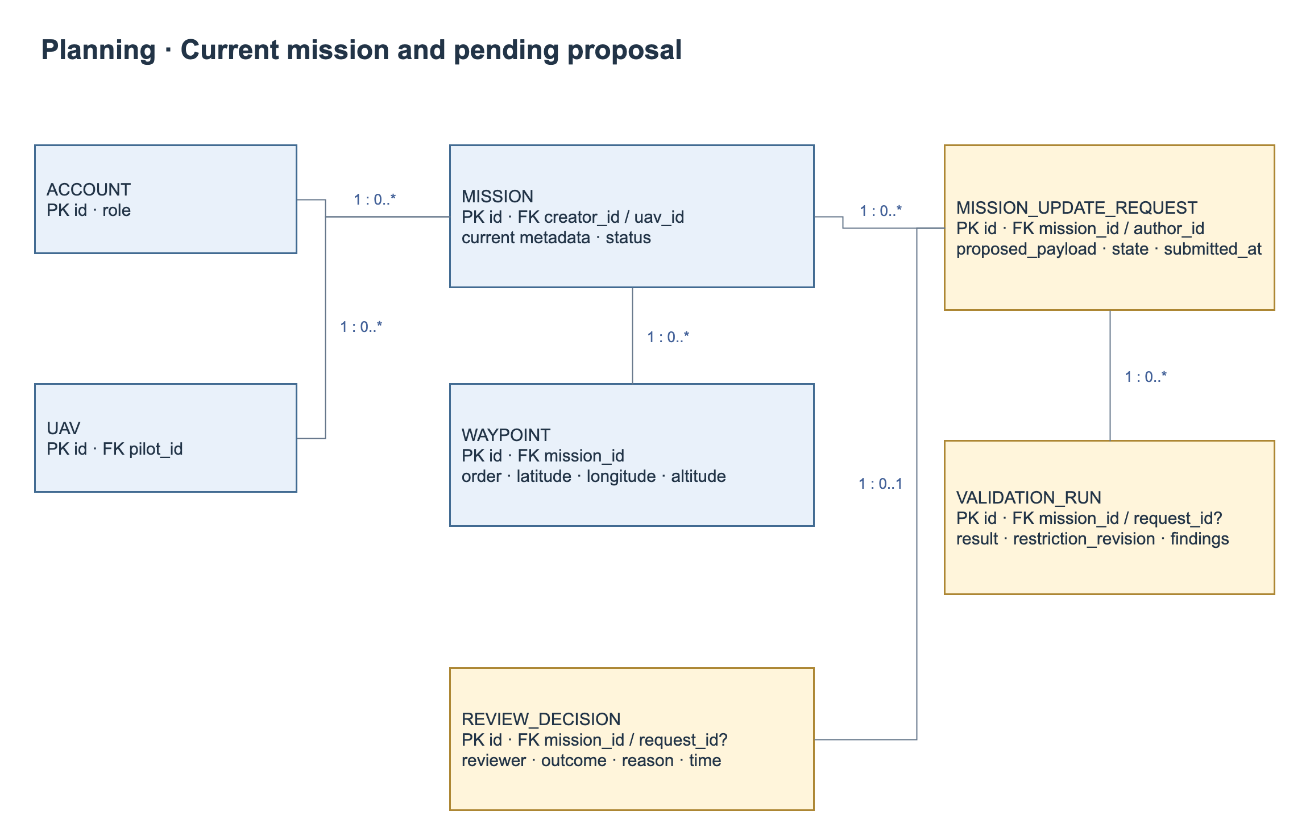
Figure 8. Logical ERD — planning, current mission, update requests and decisions.
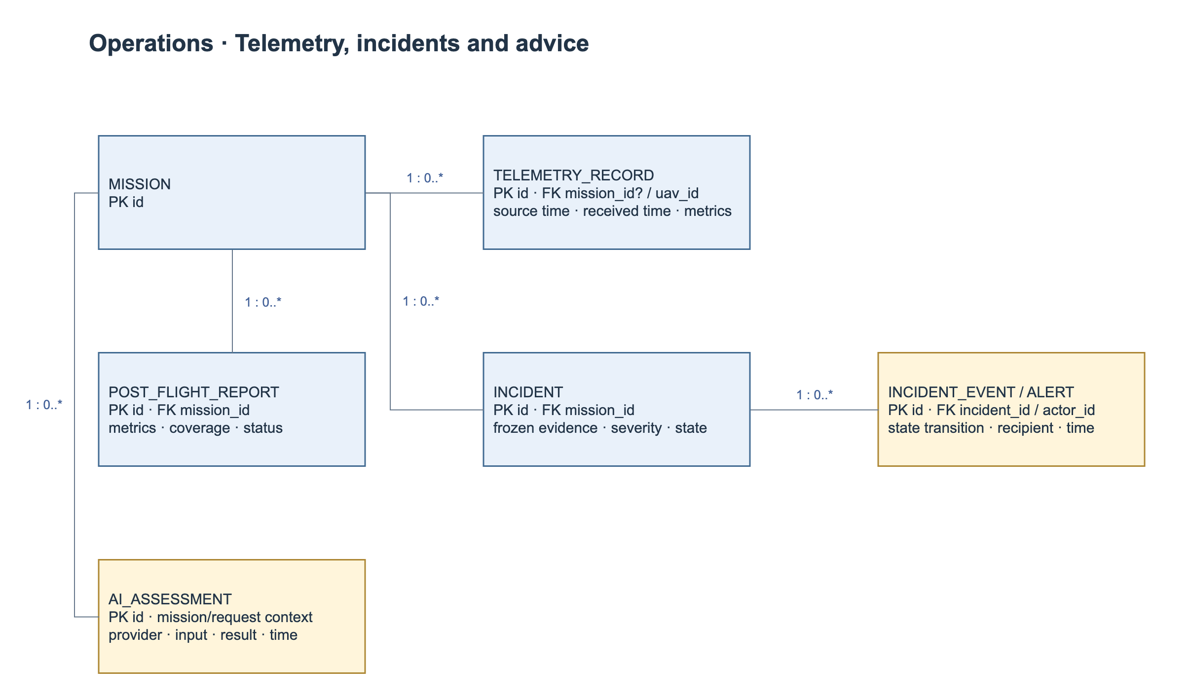
Figure 9. Logical ERD — flight evidence, incidents, post-flight reports and AI assessments.
# | Entity | Description
1 | ACCOUNT | Human identity, role and status; referenced by ownership, decisions and status events.
2 | UAV | Managed vehicle and configured telemetry identity.
3 | OPERATIONAL_AREA | Named operational geometry used by mission planning.
4 | RESTRICTION_REVISION | Configured/versioned spatial or altitude restriction in an area.
5 | MISSION | Logical mission identity, owner, assignments and current lifecycle state.
6 | MISSION_UPDATE_REQUEST | Proposed content and review state linked to one current mission. Not a separately executable mission or mission version.
7 | WAYPOINT | Ordered position/altitude in current mission; proposed route is staged in the update request until approval; connecting segments derive from order.
8 | VALIDATION_RUN | Mission/update-request-specific validation status/time and restriction snapshot.
9 | VALIDATION_FINDING | Violation/incomplete-check evidence, rule and affected waypoint/segment.
10 | APPROVAL_DECISION | Reviewer decision/reason/time for a specific plan and validation.
11 | FLIGHT | One execution record per mission, with assigned UAV/pilot and an immutable approved-plan snapshot. A repeat flight requires a new mission ID.
12 | TELEMETRY_SAMPLE | Timestamped normalized measurements; flight association may initially be unknown.
13 | INCIDENT | Detected abnormal event with source evidence and optional flight association.
14 | INCIDENT_STATUS_EVENT | Who acknowledged/resolved an incident, when and why; immutable history.
15 | POST_FLIGHT_REPORT | Generated flight report version/status and covered data window.
16 | AI_ASSESSMENT | Request context snapshot, requester/provider, result status and advisory response/error.
17 | PILOT_PROFILE | Phone, birth date and brief flight experience linked to account.
18 | PILOT_REGISTRATION | Pending pilot application, verified email and registration decision history.
19 | PILOT_LICENSE | Current approved license number, expiry, private image and approval evidence.
20 | LICENSE_CHANGE_REQUEST | Proposed license/image, pending/superseded/approved/rejected state and reviewer evidence.
21 | EMAIL_CHANGE_CHALLENGE | Account/new-email binding, protected code verifier, expiry, attempt count and delivery status.
22 | MEDIA_OBJECT | Storage identity, owner, type, validated size and access policy for avatar/license images.
23 | MISSION_FEATURE_RECORD | Completed-flight feature representation and retrieval/index configuration used for similarity evidence.

3.1.6 Mainflow Activity Diagrams
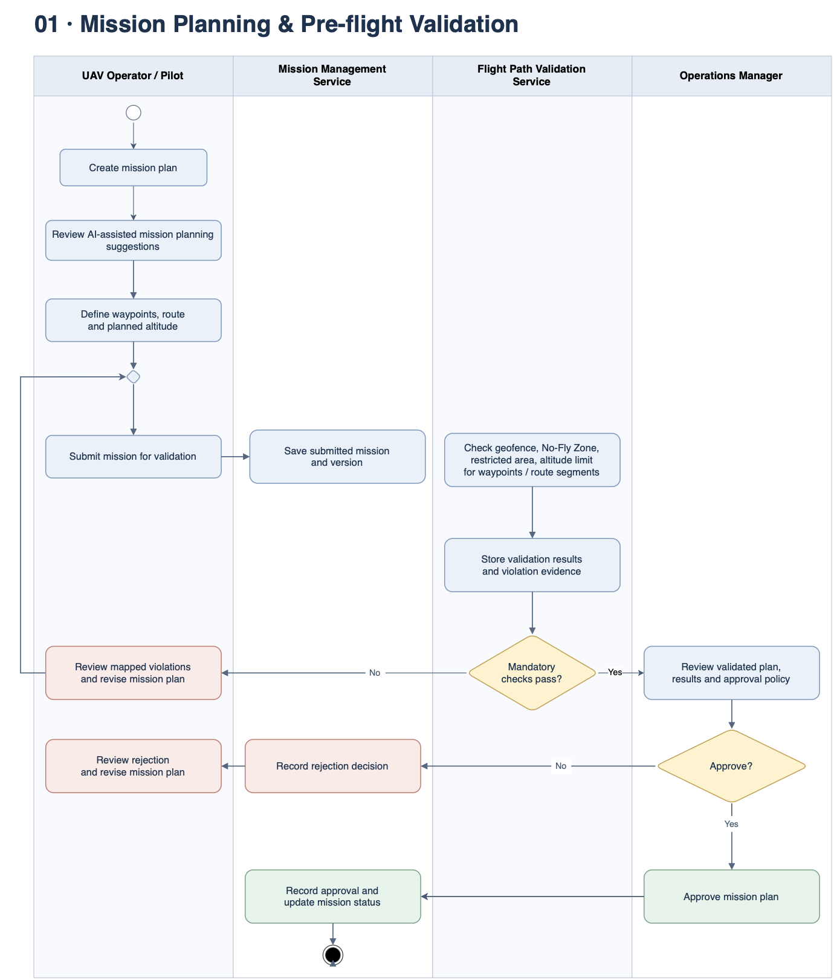
Figure 10. Mission Planning & Pre-flight Validation.
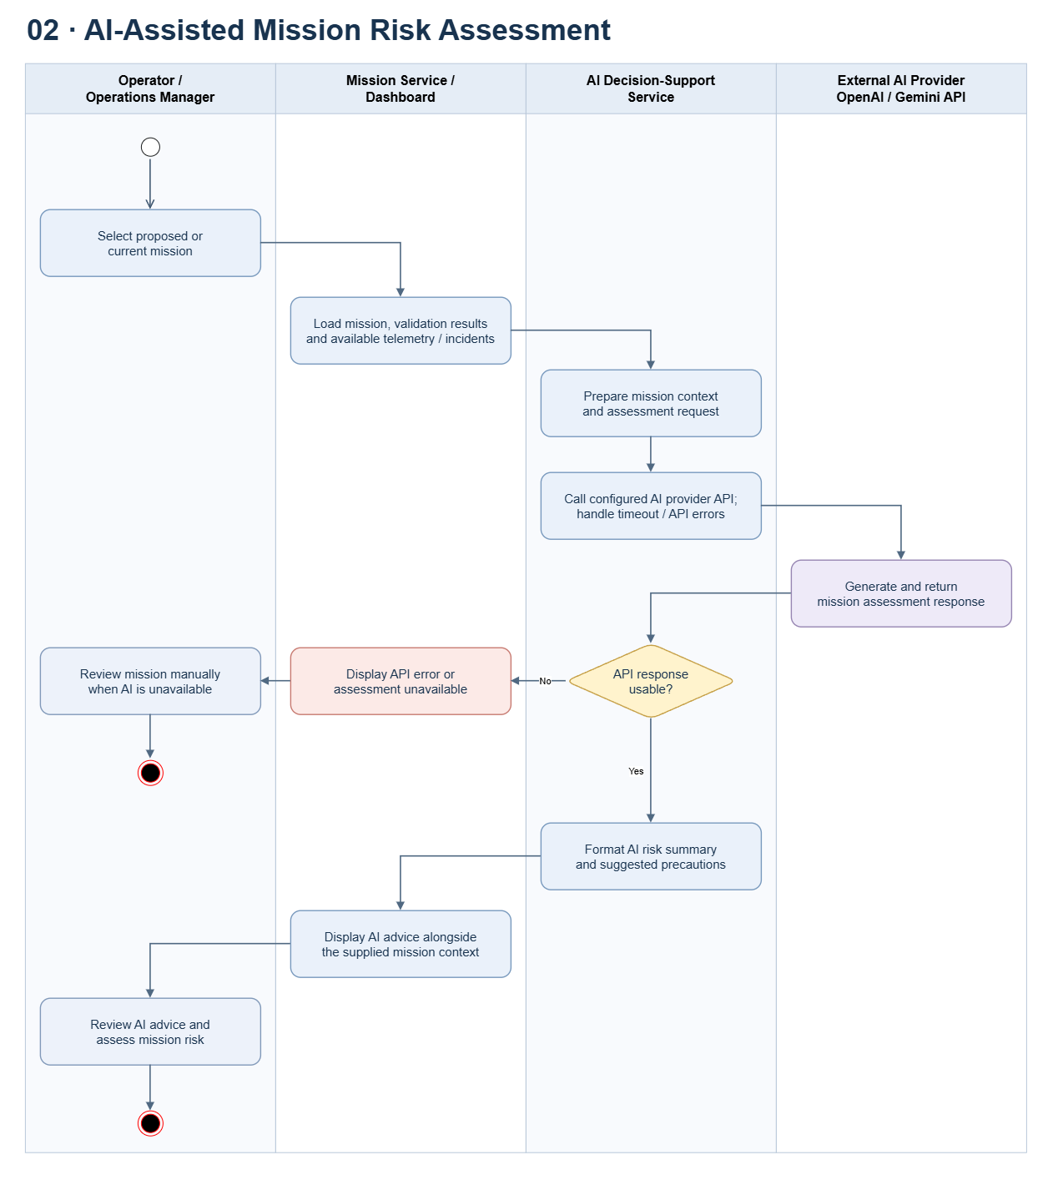
Figure 11. AI-Assisted Mission Risk Assessment.
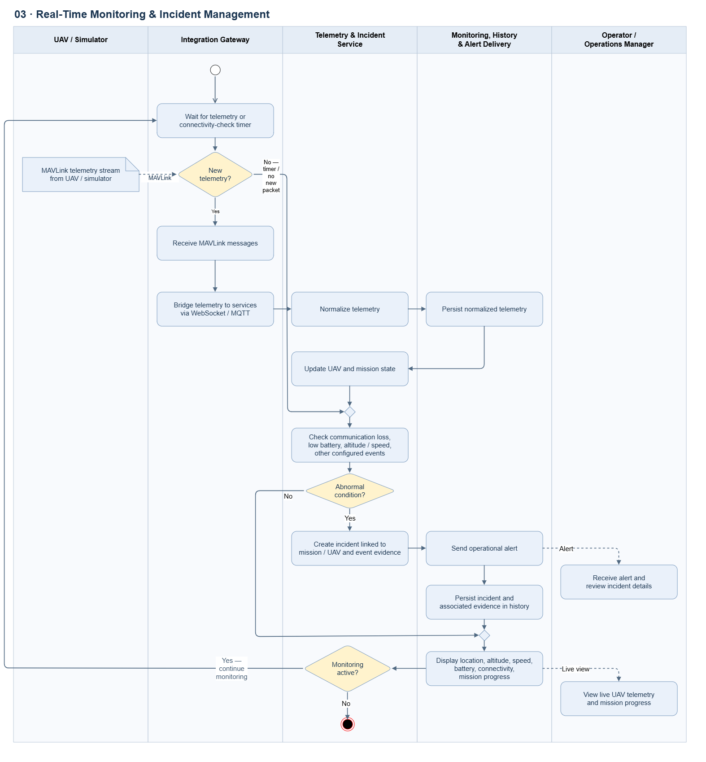
Figure 12. Real-Time Monitoring & Incident Management.
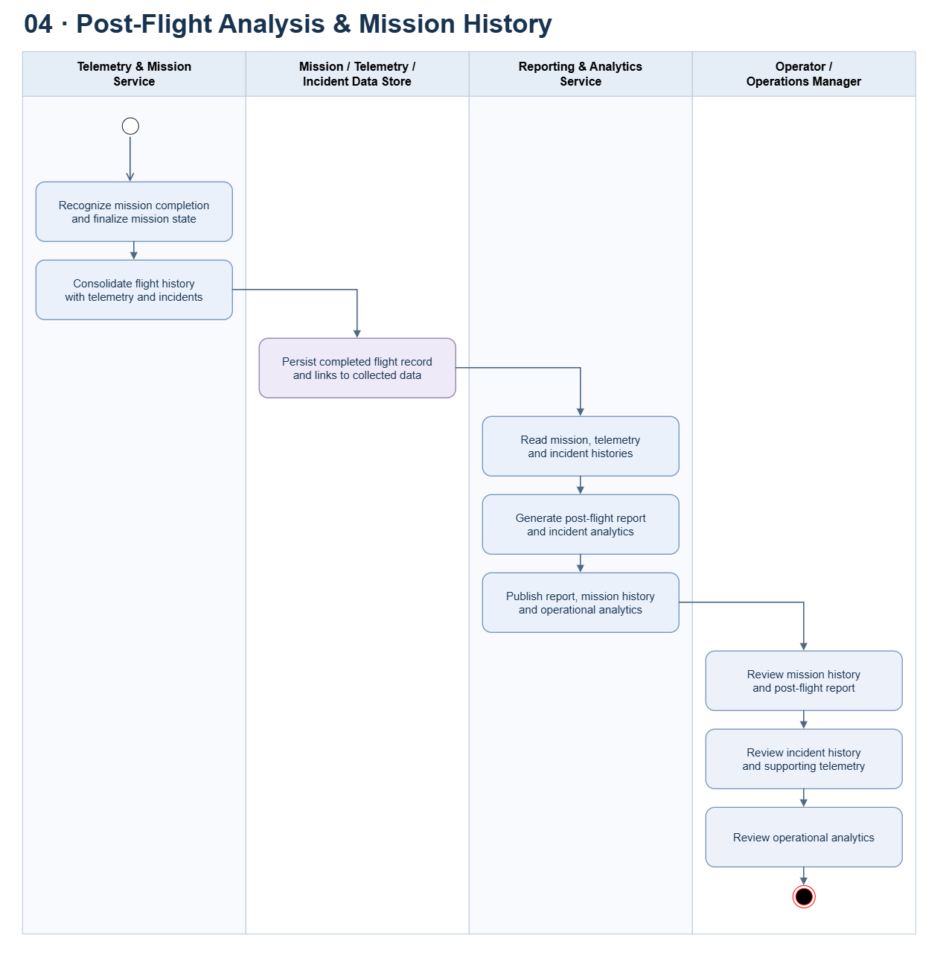
Figure 13. Post-Flight Analysis & Mission History

3.1.7 Lifecycle Diagrams
A new mission begins in Draft. Initial submission triggers validation and Manager review. Every subsequent accepted pre-flight edit creates a pending update for the same mission and automatically triggers validation and review. The current mission remains unchanged while review is pending. The lifecycle and concurrency rules are defined in BR-13 and CR-05.
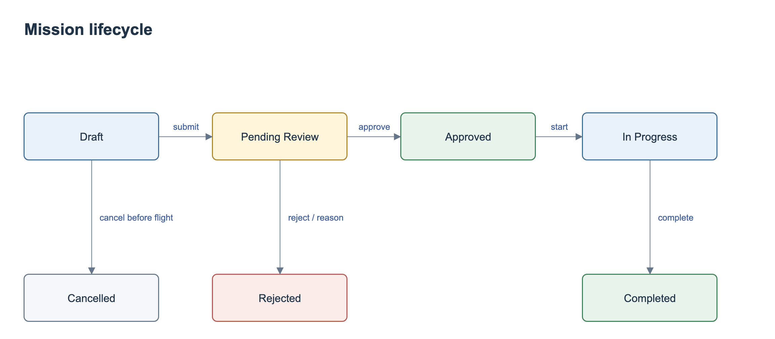
Figure 14. Mission lifecycle.
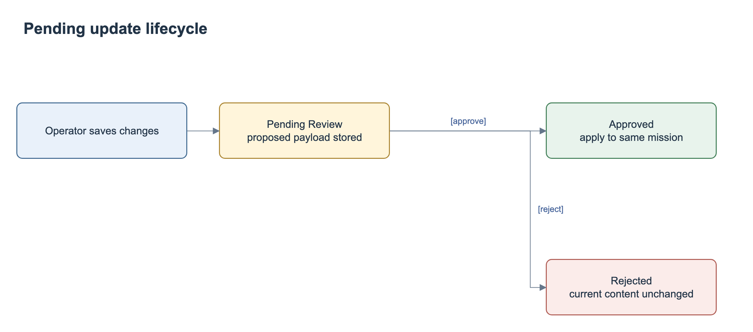
Figure 15. Pending update request lifecycle.
Approval atomically applies proposed content to the same mission ID. Rejecting an update preserves current content and operational status, including an existing Approved status. A mission with a pending update cannot begin execution. Cancellation affects the planning record and never sends a flight-control command.
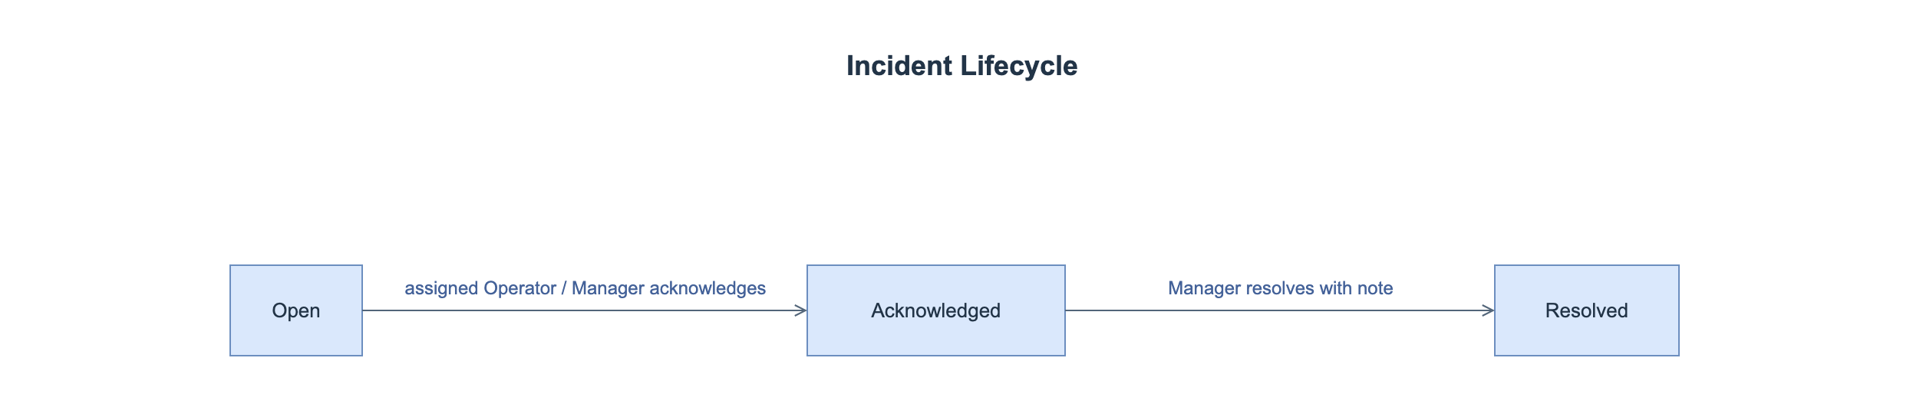
Figure 16. Incident lifecycle.

3.2 FE-01 — UAV and Operator Management

3.2.1 Sign in and sign out (UC-01)
Specification | Details
Actors / Interface | Operator; Manager | SCR-01
Trigger | Open the application or select Sign out.
Preconditions | An account is available for sign-in. Sign-out requires an active session.
Input / Data | Account identifier and password.
FR-01.1 — Normal flow | The system shall support the following behavior: Verify credentials and active account status; create a session; show only permitted navigation. Sign out invalidates the session.
FR-01.2 — Validation / Alternative flow | The system shall enforce the following checks and outcomes: Invalid credentials show MSG-02 without identifying which field is wrong; inactive account or expired session is denied; unauthorized direct URL/API access is rejected.
FR-01.3 — Postcondition | The system shall provide: Authenticated role-scoped session or signed-out state.
Business rules | BR-01; CR-01
Traceability | UC-01
Screen layout — SCR-01
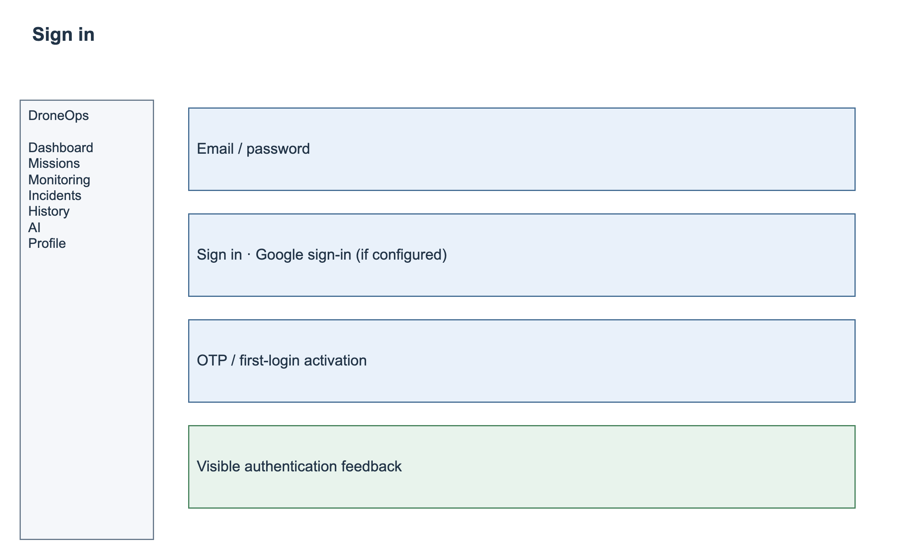
SCR-01 — Screen layout.

3.2.2 Manage UAV records (UC-02)
Specification | Details
Actors / Interface | Manager; Operator (view only) | SCR-03
Trigger | Management > UAVs > Add / Edit / Deactivate.
Preconditions | The user is authenticated and has permission to access the selected mission or record.
Input / Data | Unique UAV code, name, model, operational status and configured telemetry identity.
FR-02.1 — Normal flow | The system shall support the following behavior: List/search UAVs; validate required/unique identifiers; save a UAV record; keep historical mission references when deactivating. Operators can view assigned UAV information.
FR-02.2 — Validation / Alternative flow | Duplicate identities or invalid data shall be rejected. Conflicting updates require a reload. An operator or UAV assigned to an active mission cannot be deactivated.
FR-02.3 — Postcondition | The system shall provide: Saved UAV record and recorded actor/time of change.
Business rules | BR-02; BR-12
Traceability | UC-02
Screen layout — SCR-03
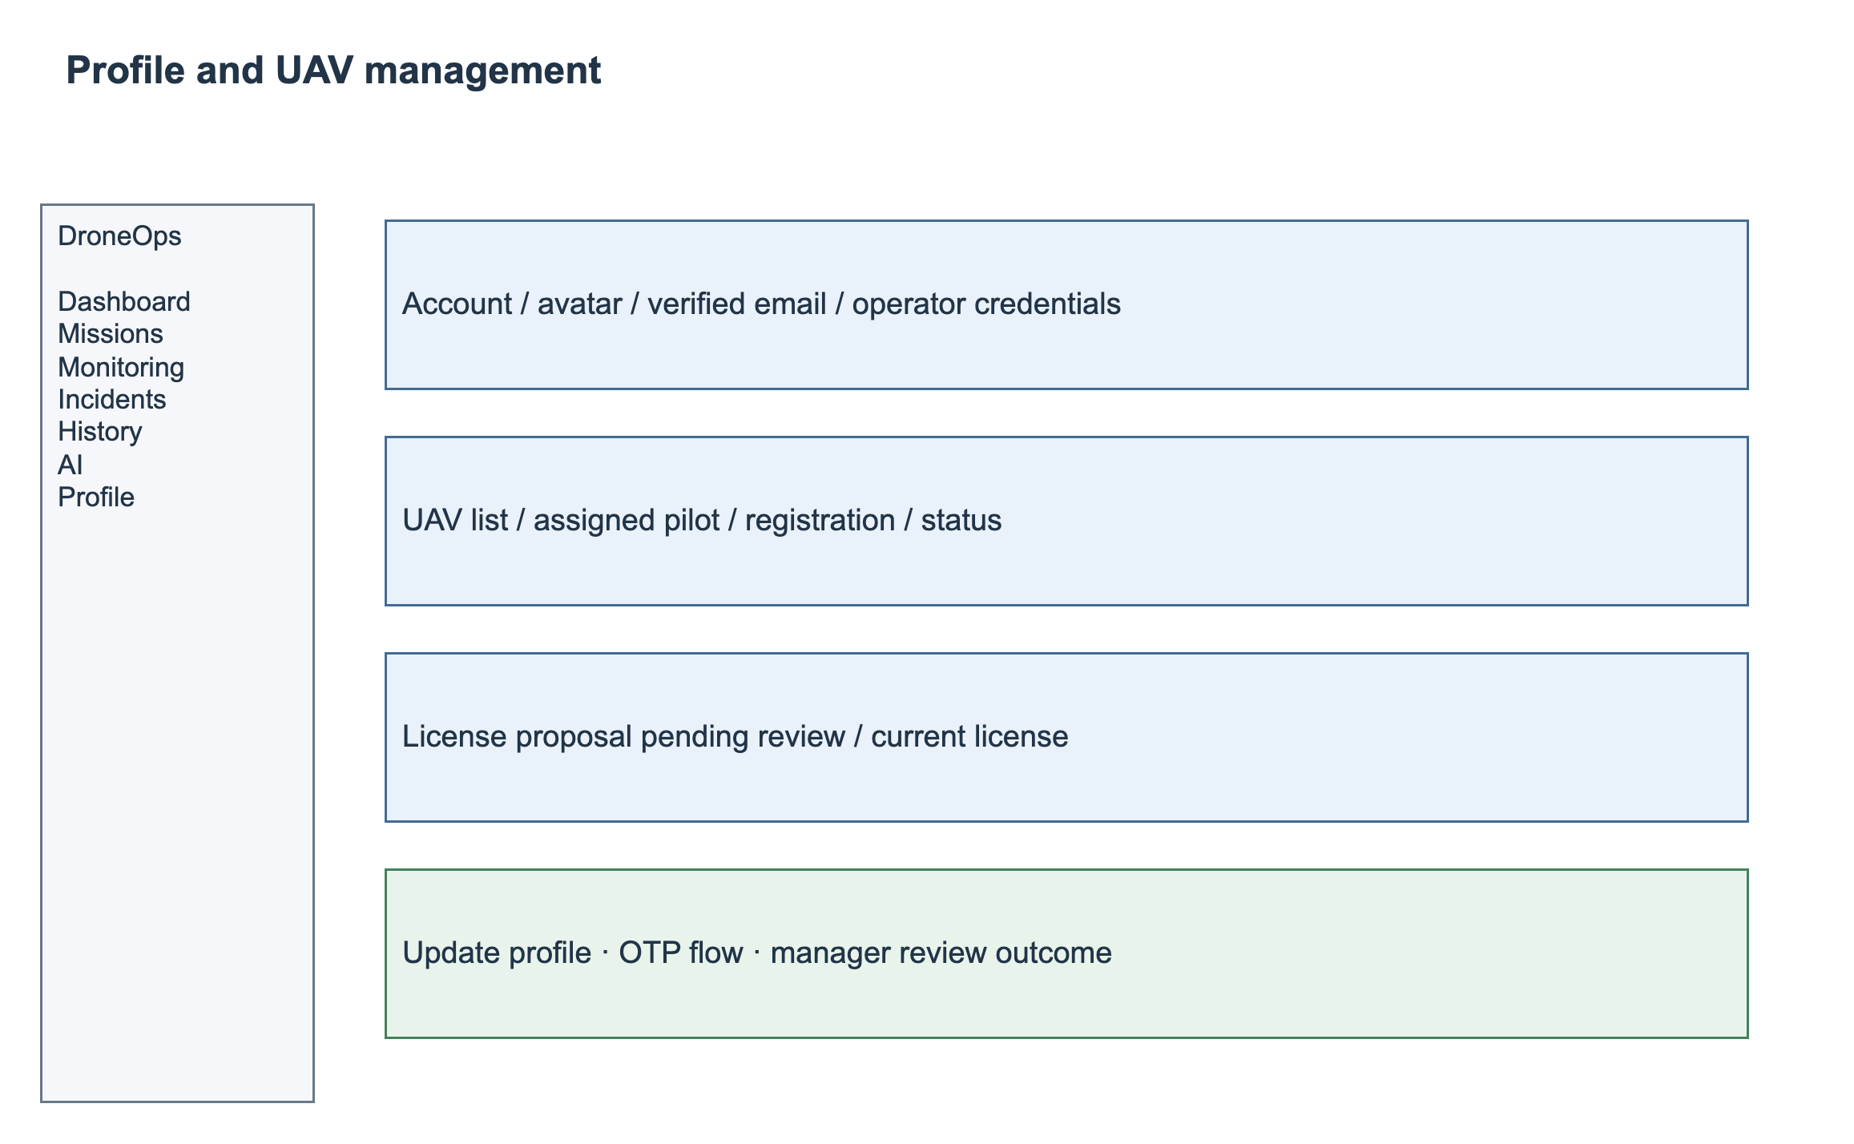
SCR-03 — Screen layout.

3.2.3 Manage operators and assignments (UC-03)
Specification | Details
Actors / Interface | Manager | SCR-04
Trigger | Management > Operators > Add / Edit / Assign.
Preconditions | The user is authenticated and has permission to access the selected mission or record.
Input / Data | Operator name, account identifier, status and mission/UAV assignment.
FR-03.1 — Normal flow | The Manager shall review pilot registrations, activate or disable eligible accounts, maintain operator assignments and retain past assignment history. Operators manage their own profile through UC-24. Only explicitly authorized administrators may provision Manager privileges.
FR-03.2 — Validation / Alternative flow | Duplicate account identifiers and inactive or ineligible assignees shall be rejected. The last active Manager cannot be disabled or demoted. A pilot with an expired, revoked or unapproved license cannot be assigned to a new flight or start a mission. Conflicting UAV/operator schedules follow BR-14.
FR-03.3 — Postcondition | The system shall provide: Updated operator/assignment records.
Business rules | BR-01; BR-02
Traceability | UC-03
Screen layout — SCR-04
SCR-04 — Screen layout.

3.2.4 Configure operational restrictions (UC-04)
Specification | Details
Actors / Interface | Manager | SCR-05
Trigger | Management > Operational Areas & Restrictions.
Preconditions | The user is authenticated and has permission to access the selected mission or record.
Input / Data | Area name, polygon/coordinates, restriction type, altitude limit and applicable reference/units.
FR-04.1 — Normal flow | The system shall support the following behavior: Create/view/edit configured operational areas, geofences, No-Fly Zones and restricted areas; validate geometry; save a restriction revision for subsequent validation.
FR-04.2 — Validation / Alternative flow | Reject empty or self-intersecting polygons, fewer than three distinct vertices, invalid coordinates, invalid altitude intervals and missing altitude reference. Persist each restriction revision. A revision affecting a route invalidates prior validation and prevents flight start until fresh validation and Manager approval are recorded. In-progress flights retain their execution snapshot and display the updated restriction warning.
FR-04.3 — Postcondition | The system shall provide: Versioned operational restrictions available to validation.
Business rules | BR-03; BR-04
Traceability | UC-04
Screen layout — SCR-05
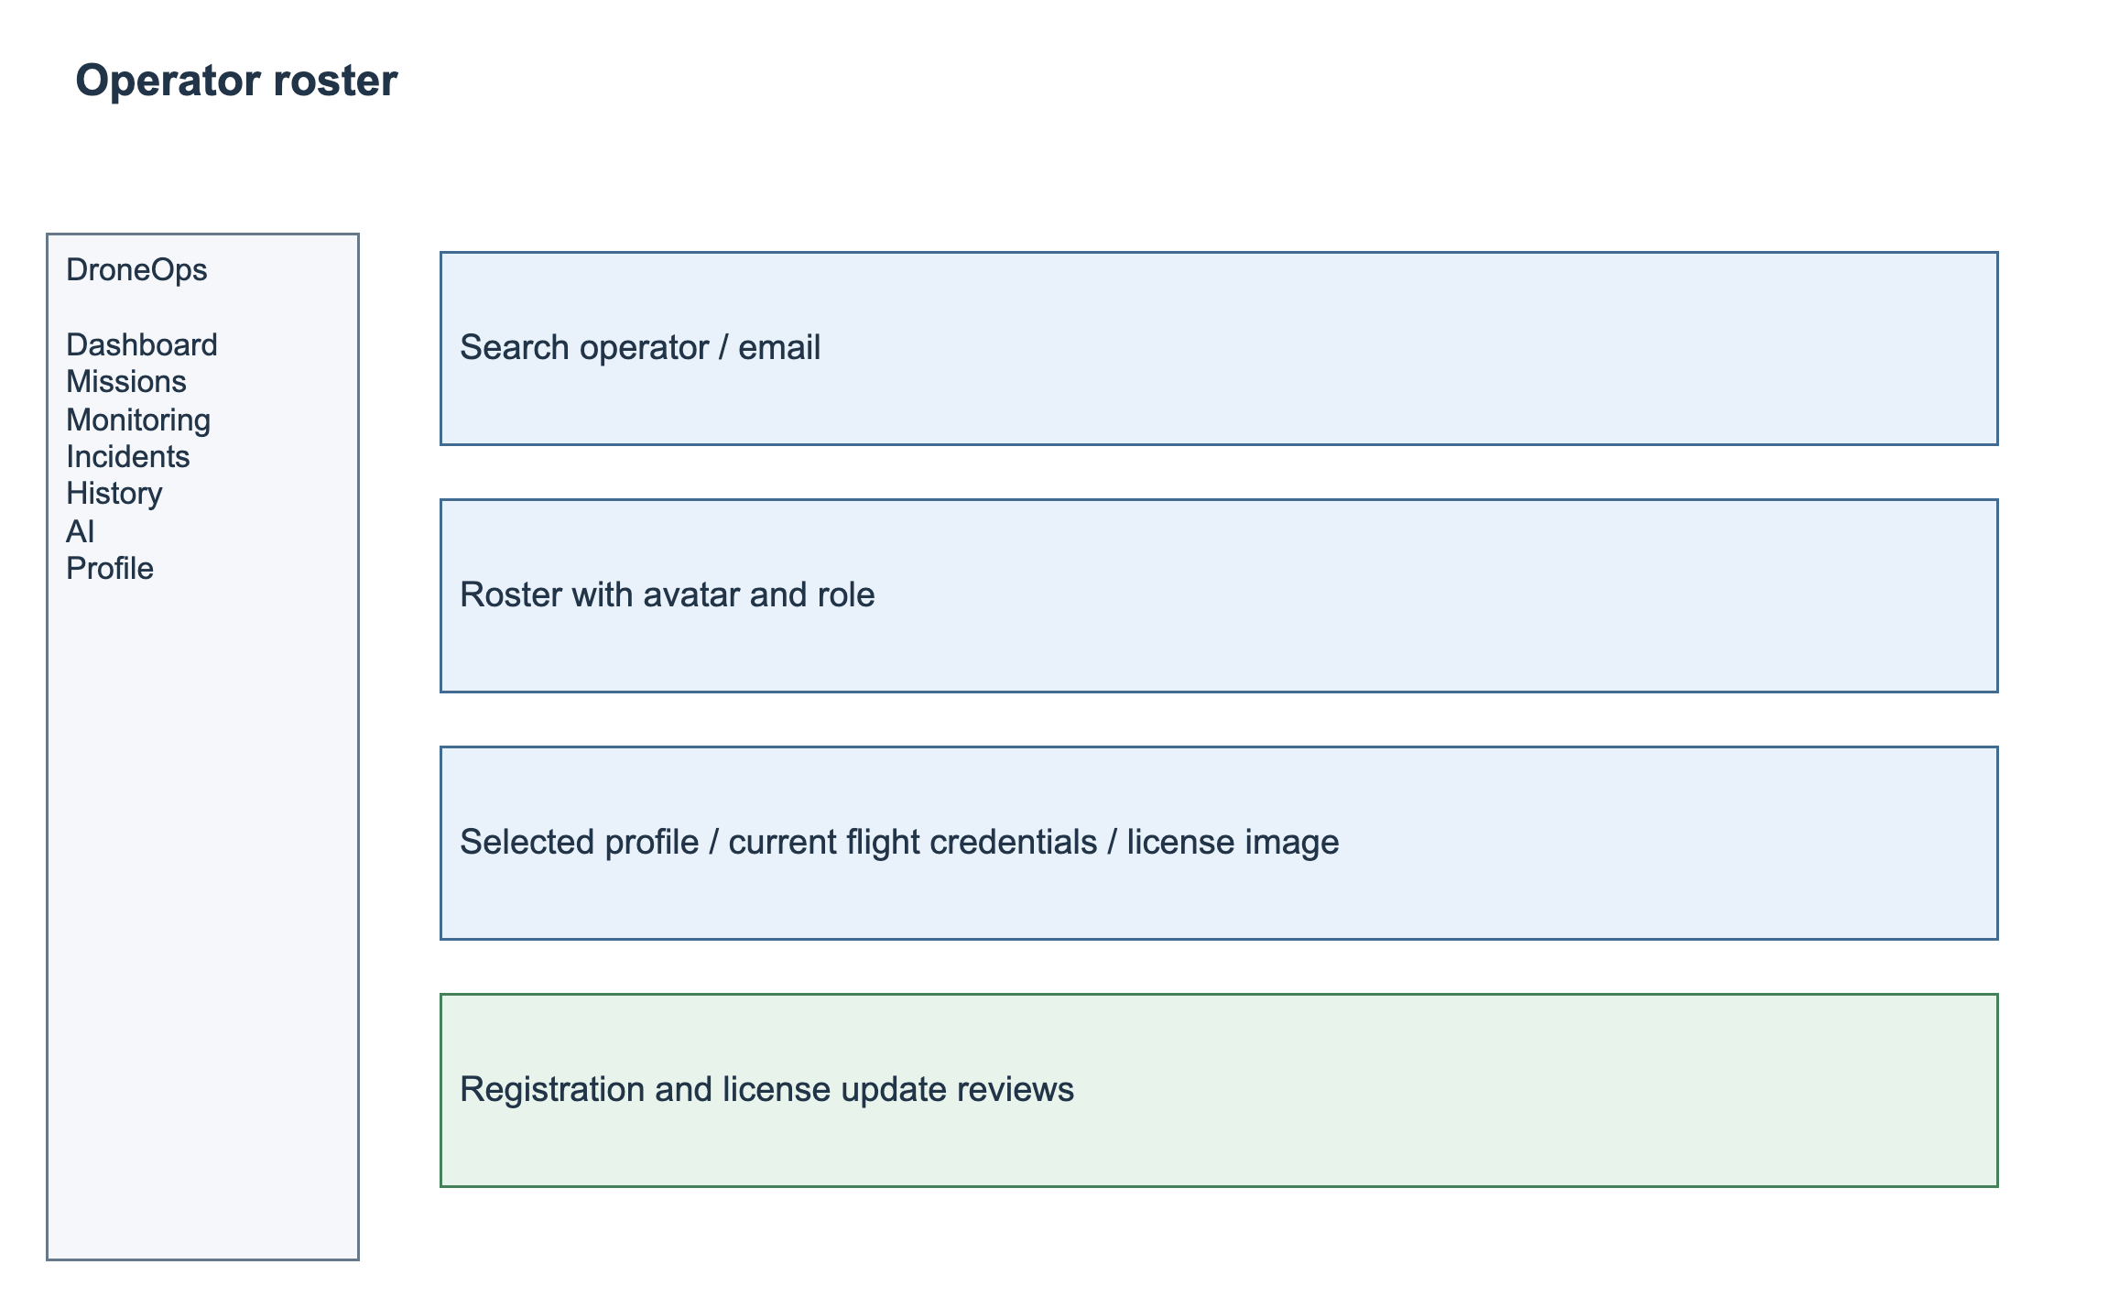
SCR-05 — Screen layout.

3.2.5 Register a pilot account and review registration (UC-23)
Specification | Details
Actors / Interface | Applicant; Manager | SCR-17 / SCR-04
Trigger | Open Register; Manager opens Registration Requests.
Preconditions | Registration is public; review requires an authenticated authorized Manager.
Input / Data | Full name, unique email, password, phone, date of birth, brief flight experience, license number/expiry and JPEG/PNG/WebP license image up to 5 MB.
FR-23.1 — Normal flow | Validate fields, verify email using a one-time code and create Pending Review registration. Manager reviews identity and license evidence, approves or rejects with a reason, and records the decision. Approval activates Operator access; pending/rejected accounts cannot access operational functions.
FR-23.2 — Validation / Alternative flow | Reject duplicate normalized email, invalid phone/date, expired license or unsupported upload. Email verification uses a six-digit code valid for 10 minutes, at most five attempts and a 60-second resend interval; resending invalidates the prior code. A rejected application may be corrected and resubmitted without creating a second account. Review retries are idempotent; applicants cannot select Manager privileges.
FR-23.3 — Postcondition | Verified registration and immutable review outcome; only approved pilots receive operational access.
Business rules | BR-01; BR-12; BR-16; BR-17; CR-01; CR-02; CR-05
Traceability | UC-23

3.2.6 Edit profile and avatar (UC-24)
Specification | Details
Actors / Interface | Operator; Manager (own profile) | SCR-18
Trigger | Profile > Edit details or Change avatar.
Preconditions | Authenticated account.
Input / Data | Phone, date of birth, brief flight experience and optional avatar image.
FR-24.1 — Normal flow | Allow the user to update their own phone, date of birth and brief flight experience, and replace their avatar. Show the saved avatar in the profile and authorized Manager operator roster/detail. Use the label Briefly describe your flight experience.
FR-24.2 — Validation / Alternative flow | Require a nonfuture birth date and valid phone; do not accept profile fields that change role, account status or approved license. Accept JPEG/PNG/WebP up to 5 MB, validate file content and retain the previous avatar on failure. Stale updates require reload.
FR-24.3 — Postcondition | Saved profile fields and avatar with visible success/error feedback.
Business rules | BR-01; BR-12; BR-16; BR-17; CR-01; CR-02; CR-05
Traceability | UC-24

3.2.7 Change email with verification (UC-25)
Specification | Details
Actors / Interface | Operator; Manager (own account) | SCR-19
Trigger | Profile > Change email > Send verification code > Confirm.
Preconditions | Authenticated account; proposed email differs from the current one.
Input / Data | New email and verification code.
FR-25.1 — Normal flow | Reject an already registered normalized email before sending a code. Send the code to the new address and visibly state the destination. Keep the current email until confirmation succeeds. On success atomically reserve the unique new email, update the account and invalidate pending codes.
FR-25.2 — Validation / Alternative flow | Use a six-digit code valid for 10 minutes, maximum five verification attempts and a 60-second resend interval. A resend invalidates the previous code. Scope the challenge to account and proposed email; store a protected verifier, never the raw code. Delivery failure leaves the current email unchanged. Recheck uniqueness on confirmation and require reauthentication after change.
FR-25.3 — Postcondition | Verified new account email or unchanged current email on any failure.
Business rules | BR-01; BR-12; BR-16; BR-17; CR-01; CR-02; CR-05
Traceability | UC-25

3.2.8 Request and review a license change (UC-26)
Specification | Details
Actors / Interface | Operator; Manager reviewer | SCR-20 / SCR-21
Trigger | Profile > Flight credentials > Request change; Manager > License Changes.
Preconditions | Authenticated pilot for submission; scoped Manager other than request author for decision.
Input / Data | Proposed license number, expiry date and private supporting image.
FR-26.1 — Normal flow | Store proposed credentials and image separately and create Pending Review request. Display current license and request status to the pilot. Manager sees the pilot avatar/profile, current and proposed credentials and accessible images; Approve atomically replaces current credentials, Reject retains them and requires a reason. Notify the pilot in-app and retain decision history.
FR-26.2 — Validation / Alternative flow | Require a future expiry, nonblank license number and valid JPEG/PNG/WebP up to 5 MB. Permit one pending request per account; a replacement supersedes the prior pending request and cannot be approved from a stale screen. Failed upload cannot create an incomplete request. Rejection does not extend the old license validity.
FR-26.3 — Postcondition | Approved replacement or unchanged current credentials with traceable pending/rejected outcome.
Business rules | BR-01; BR-12; BR-16; BR-17; CR-01; CR-02; CR-05
Traceability | UC-26

3.3 FE-02 — Mission Planning and Management

3.3.1 Create a mission plan (UC-05)
Specification | Details
Actors / Interface | Operator | SCR-07
Trigger | Missions > New Mission.
Preconditions | The Operator is authenticated and an eligible assigned UAV is available.
Input / Data | Name, purpose, UAV/operator, operational area and proposed schedule if used.
FR-05.1 — Normal flow | Create a Draft mission with one mission ID and the selected owner, UAV, operational area and scheduled start/end. The creation form may save an initial ordered route without review. After creation, accepted changes follow UC-06; initial submission follows UC-08. No mission versions are created.
FR-05.2 — Validation / Alternative flow | Require a name, active UAV, eligible assigned pilot, valid operational area and an end time later than the start time. Reject conflicting UAV/pilot bookings. A route requires at least two ordered waypoints before submission. Warn before navigating away from unsaved form changes.
FR-05.3 — Postcondition | The system shall provide: Draft mission owned by the creator.
Business rules | BR-02; BR-05
Traceability | UC-05

Screen layout — SCR-07
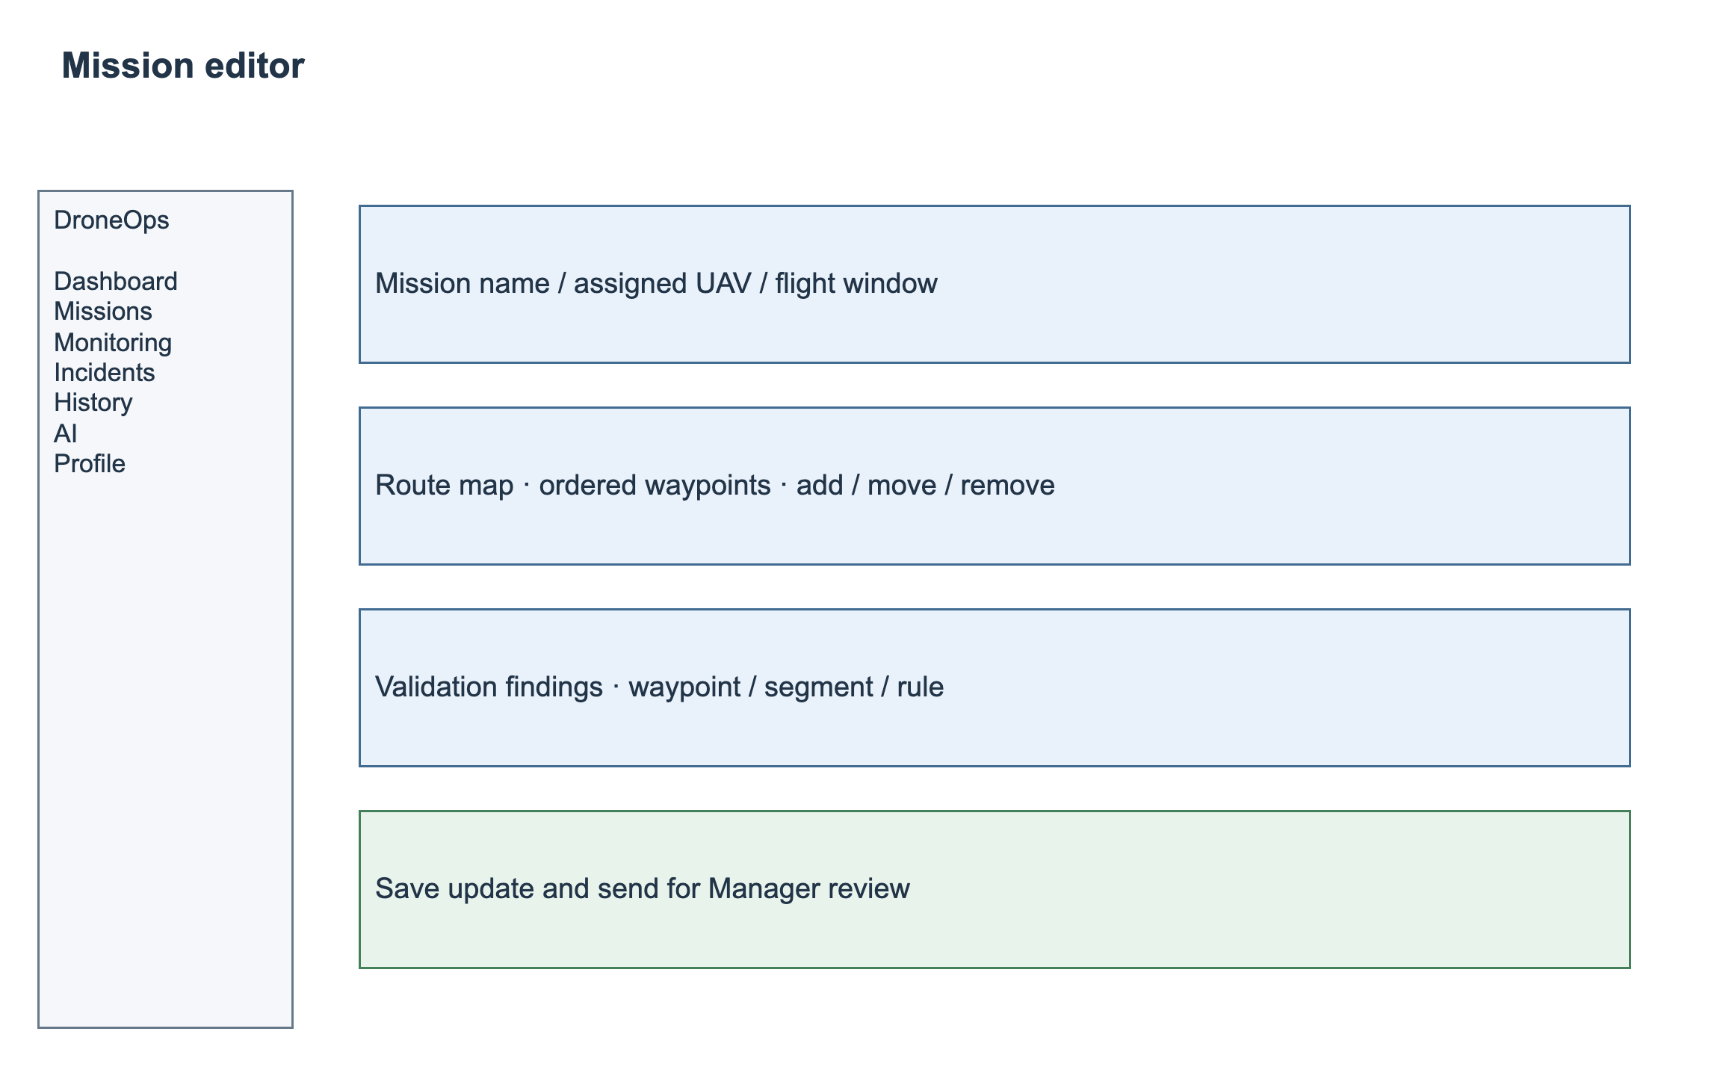
SCR-07 — Screen layout.

3.3.2 Edit a route and request mission updates (UC-06)
Specification | Details
Actors / Interface | Operator; Manager | SCR-07
Trigger | Missions > Mission Details > Edit Plan.
Preconditions | The mission exists within the user’s scope and has not entered execution.
Input / Data | Ordered waypoint coordinates and planned altitude; mission metadata.
FR-06.1 — Normal flow | An authorized Operator or Manager may propose metadata, schedule, assignment and route changes to an eligible pre-flight mission. Each accepted Save stores a complete proposed payload separately, creates a request identity, runs validation and automatically sends the request to Manager review. The current mission content and status remain unchanged until approval; no second manual Submit is required.
FR-06.2 — Validation / Alternative flow | Reject changes to In Progress, Completed or Cancelled missions, malformed coordinates, invalid assignments and schedule conflicts. Only one pending update may exist per mission. A later accepted Save atomically supersedes the earlier pending request, preserves its history and invalidates its evidence; the superseded request cannot be decided. A stale form or decision returns a conflict and requires reload. Proposed content cannot reuse validation for different content.
FR-06.3 — Postcondition | The system shall provide: Proposed update stored with author/time and automatically sent to Manager; current mission remains unchanged until approval.
Business rules | BR-04; BR-05; BR-06
Traceability | UC-06

3.3.3 View or cancel a mission plan (UC-07)
Specification | Details
Actors / Interface | Operator; Manager | SCR-06 / SCR-08
Trigger | Missions > select mission; choose Cancel if permitted.
Preconditions | The user is authenticated and has permission to access the selected mission or record.
Input / Data | Mission ID, search/filter and cancellation reason.
FR-07.1 — Normal flow | The system shall support the following behavior: Display current mission, proposed updates, validation and decisions. If cancellation is permitted, confirm the action, preserve history and mark the plan Cancelled.
FR-07.2 — Validation / Alternative flow | Draft, Pending Review, Rejected and Approved missions may be cancelled by an authorized owner/assigned Operator or scoped Manager with a nonblank reason. Cancellation closes any pending submission/update as Cancelled, retains decisions and releases future bookings. In Progress, Completed and already Cancelled missions cannot be cancelled by this action.
FR-07.3 — Postcondition | The system shall provide: Mission details shown or planning record cancelled with audit evidence.
Business rules | BR-01; BR-05; BR-06
Traceability | UC-07
Screen layout — SCR-06
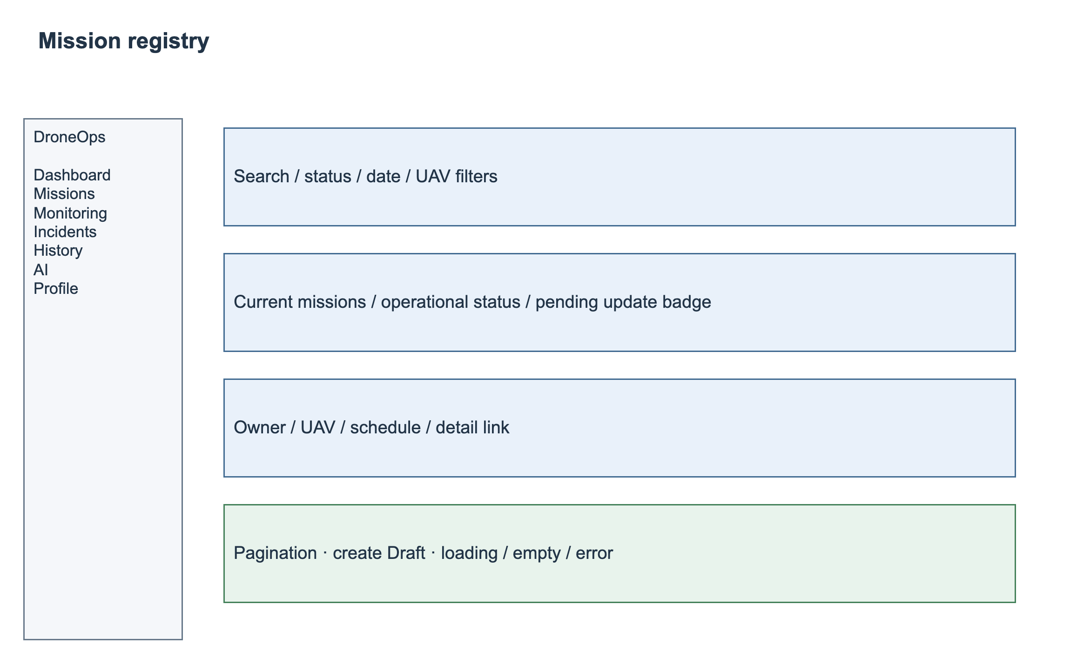
SCR-06 — Screen layout.
Screen layout — SCR-08
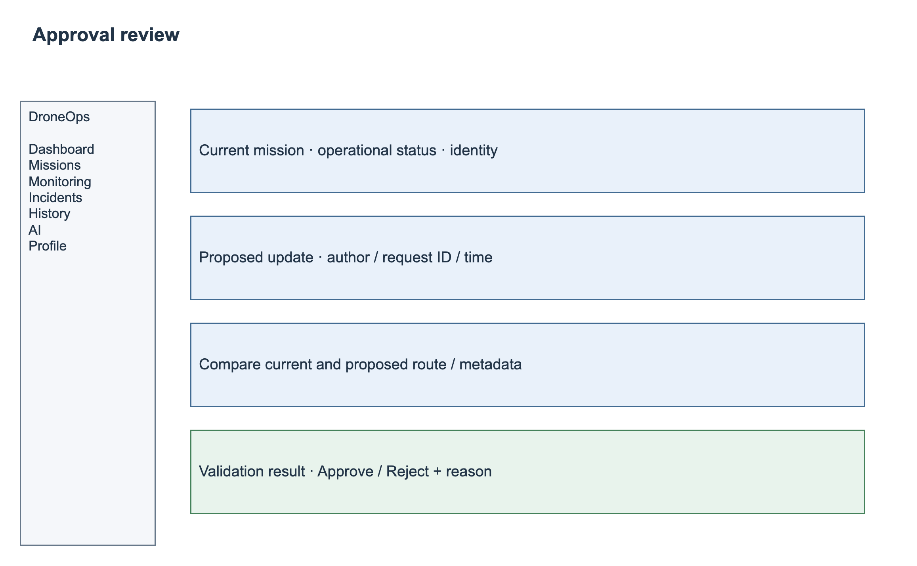
SCR-08 — Screen layout.

3.4 FE-03 — Mission Approval Workflow

3.4.1 Submit a mission for validation (UC-08)
Specification | Details
Actors / Interface | Operator | SCR-08
Trigger | Mission Details > Submit.
Preconditions | The mission has a saved route and required assignment data.
Input / Data | Current mission or proposed update request with route and required assignment data.
FR-08.1 — Normal flow | For an initial Draft or Rejected mission, Submit validates required fields, assignments and schedule, captures the submitted plan, invokes UC-11 and moves the mission to Pending Review. For an edit to an existing mission, Save already creates the review request and invokes validation through UC-06. Failed, incomplete or stale results remain visible to the Manager and block approval; they do not authorize flight.
FR-08.2 — Validation / Alternative flow | Missing required fields prevent acceptance. Validation service failure produces Error or Incomplete, never Pass. Retrying the same operation identity returns the existing result rather than creating another submission. Initial submitted content cannot be overwritten in place; a subsequent edit follows the reviewed-update policy and supersedes the previous pending review.
FR-08.3 — Postcondition | The system shall provide: Mission/update request visible to Manager with validation outcome; failed/incomplete/stale checks block approval.
Business rules | BR-03; BR-05; BR-06
Traceability | UC-08

3.4.2 Approve or reject a mission (UC-09)
Specification | Details
Actors / Interface | Manager | SCR-09
Trigger | Approvals > select pending mission.
Preconditions | The Manager is authenticated and the submission or update request is awaiting review.
Input / Data | Current mission, proposed content, update request ID, validation evidence and decision reason.
FR-09.1 — Normal flow | The Manager shall compare current and submitted/proposed content and check fresh mandatory validation and assignment eligibility. For an initial submission, Approve changes the mission to Approved and Reject changes it to Rejected. For an update, Approve atomically applies the proposed content to the same mission ID and sets Approved; Reject changes only the request to Rejected and preserves current content and mission status. Record reviewer, time, reason and reviewed payload/evidence identity; notify the Operator in-app.
FR-09.2 — Validation / Alternative flow | Require a nonblank rejection reason. The author of a proposed update cannot approve it; another authorized Manager must decide it. Pending requests may be rejected even when validation failed, but approval requires Pass against current restrictions and unchanged proposed content. Stale, superseded, cancelled or already decided requests cannot receive a conflicting decision. Repeated identical decisions are idempotent. Concurrent content/restriction changes force refresh and revalidation.
FR-09.3 — Postcondition | The system shall provide: Immutable decision linked to mission and review request; approve applies proposed content, reject preserves existing content and prior approval.
Business rules | BR-03; BR-05; BR-06
Traceability | UC-09
Screen layout — SCR-09
SCR-09 — Screen layout.

3.4.3 Review approval history (UC-10)
Specification | Details
Actors / Interface | Operator; Manager | SCR-08
Trigger | Mission Details > Updates & Decisions.
Preconditions | The user is authenticated and has permission to access the selected mission or record.
Input / Data | Mission ID and selected update request ID, where applicable.
FR-10.1 — Normal flow | The system shall support the following behavior: Show submission, validation, decision, reviewer/time and rejection reasons in order; scope operator access to permitted missions.
FR-10.2 — Validation / Alternative flow | The system shall enforce the following checks and outcomes: No prior decision displays an empty state; inaccessible mission/update request is denied.
FR-10.3 — Postcondition | The system shall provide: Traceable approval history.
Business rules | BR-01; BR-06
Traceability | UC-10

3.5 FE-04 — Geofence and Flight Path Validation

3.5.1 Validate waypoints and route segments (UC-11)
Specification | Details
Actors / Interface | Operator (via submission) | SCR-08 / background
Trigger | Submission or an authorized revalidation request.
Preconditions | The mission route and active configured restrictions are available for validation.
Input / Data | Current mission route or proposed update payload and current configured restrictions.
FR-11.1 — Normal flow | Validate all waypoints and their connecting straight segments against active operational boundaries, No-Fly Zones, restricted polygons and altitude limits. Use WGS84 latitude/longitude in decimal degrees and metres above mean sea level (MSL) for planned altitude. A route touching or crossing a prohibited polygon boundary is a violation; an operational-area boundary is included. Persist Pass/Fail/Incomplete/Error, affected waypoint/segment, rule, restriction revision and checked payload identity.
FR-11.2 — Validation / Alternative flow | Latitude shall be within [-90, 90] and longitude within [-180, 180]. Require at least two waypoints and unique contiguous sequence numbers. Polygon rings must be closed, non-self-intersecting and contain at least three distinct vertices. Altitude limits are inclusive; no-flight restrictions override allowed areas. AGL-only restrictions require an available terrain/reference conversion to MSL; missing conversion or restriction data produces Incomplete. Empty configured prohibited-zone results are distinct from an unavailable restriction service.
FR-11.3 — Postcondition | The system shall provide: Mission/update-request-linked validation result and map evidence.
Business rules | BR-03; BR-04
Traceability | UC-11

3.5.2 Review mapped validation results (UC-12)
Specification | Details
Actors / Interface | Operator; Manager | SCR-08
Trigger | Mission Details > Validation.
Preconditions | The user is authenticated and has permission to access the selected mission or record.
Input / Data | Validation run ID, mission ID and optional update request ID.
FR-12.1 — Normal flow | The system shall support the following behavior: Highlight failed waypoints/segments on the map; list violated configured rule and explanation; show pass/fail/incomplete and validation timestamp.
FR-12.2 — Validation / Alternative flow | The system shall enforce the following checks and outcomes: Map provider failure leaves a textual violation list accessible; an old run is labelled outdated.
FR-12.3 — Postcondition | The system shall provide: User can locate violations and decide whether to edit/resubmit.
Business rules | BR-03; BR-06
Traceability | UC-12

3.6 FE-05 — MAVLink Telemetry Integration

3.6.1 Provide and ingest telemetry (UC-13)
Specification | Details
Actors / Interface | UAV/Autopilot or Simulator | Non-screen
Trigger | Configured source sends MAVLink data to the integration gateway.
Preconditions | A configured telemetry source identifies the UAV and supplies a timestamped sample.
Input / Data | Source identity, message timestamp and supported location/altitude/speed/battery/state fields.
FR-13.1 — Normal flow | The system shall support the following behavior: Accept a configured source; normalize units/fields; persist timestamps and validity; associate data with the correct UAV and, when known, flight; update latest valid state and publish an update.
FR-13.2 — Validation / Alternative flow | Reject malformed packets and unknown source/UAV mappings; retain diagnostics without treating missing values as zero. Deduplicate using source identity, boot/session identity, message type and source sequence/time. Exact replay creates no second persisted event. Out-of-order samples may be retained as historical evidence but cannot replace newer live state or create retrospective live alerts. A configured UAV may map to at most one active flight; ambiguous data remains unassociated and cannot advance a mission state.
FR-13.3 — Postcondition | The system shall provide: Stored telemetry and updated UAV/mission projection without flight-control commands.
Business rules | BR-07; BR-08
Traceability | UC-13

3.7 FE-06 — Real-Time Mission Monitoring

3.7.1 Monitor an active mission (UC-14)
Specification | Details
Actors / Interface | Operator; Manager | SCR-10
Trigger | Live Monitoring > select active mission/UAV.
Preconditions | The user is authenticated and has permission to access the selected mission or record.
Input / Data | Authorized mission/UAV selection and live telemetry projection.
FR-14.1 — Normal flow | Display authorized live position, altitude with reference, speed, battery percentage, connectivity, source/received timestamps, freshness and mission progress. Progress is the count of confirmed reached planned waypoints divided by the execution snapshot waypoint count, expressed as a percentage; absent reliable waypoint progress is Unavailable. Live state updates as accepted samples arrive and links to related incidents.
FR-14.2 — Validation / Alternative flow | The system shall enforce the following checks and outcomes: No packet/stale stream shows last-known values with timestamp and stale/offline status; never imply stale values are live; reconnect refreshes the latest valid state.
FR-14.3 — Postcondition | The system shall provide: Real-time operational view with explicit freshness.
Business rules | BR-07; BR-08
Traceability | UC-14
Screen layout — SCR-10
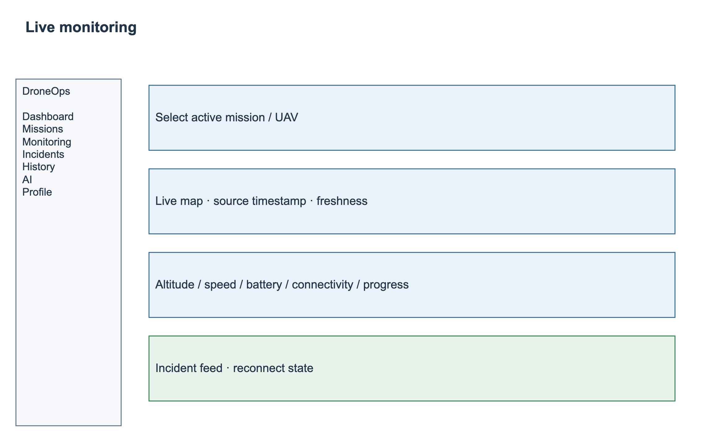
SCR-10 — Screen layout.

3.8 FE-07 — Operational Alert and Incident Detection

3.8.1 Detect incidents and deliver alerts (UC-15)
Specification | Details
Actors / Interface | UAV/Simulator (data source); Operator; Manager | SCR-10 / SCR-11 / background
Trigger | Accepted telemetry or connectivity-check timer.
Preconditions | A configured source/UAV mapping and enabled detection rules exist. Background evaluation uses an authorized integration identity and does not require a human session.
Input / Data | Telemetry, last-seen time and configured abnormal-event rules.
FR-15.1 — Normal flow | The system shall support the following behavior: Evaluate communication loss, low battery and abnormal altitude/speed; create an incident linked to UAV/mission and evidence; persist it and deliver an in-app alert to permitted users. Run communication-loss checks even with no new packet.
FR-15.2 — Validation / Alternative flow | Missing measurements disable only the affected rule and expose Unavailable. Deduplicate incidents by UAV, rule and abnormal episode, including concurrent timer/packet evaluation. A delivery failure retains the incident and unread in-app alert for subsequent retrieval. Recovery follows BR-15; acknowledgement or resolution cannot manufacture a recovery sample.
FR-15.3 — Postcondition | The system shall provide: Persisted incident and available in-app alert; no autonomous control action.
Business rules | BR-08; BR-09
Traceability | UC-15

Screen layout — SCR-11
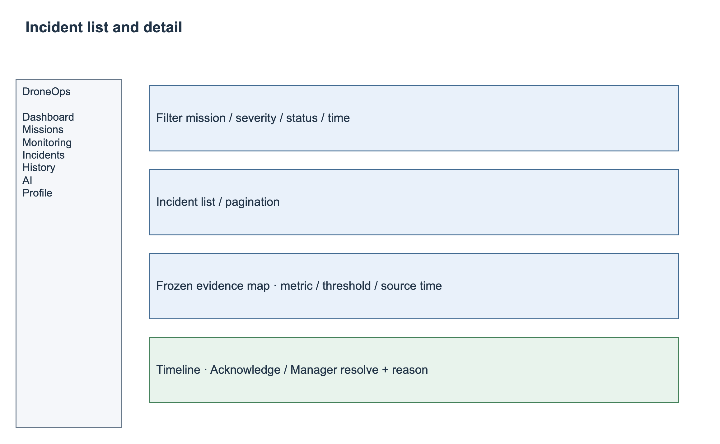
SCR-11 — Screen layout.
Detection rules use the configured thresholds and recovery conditions in BR-15. One continuous abnormal episode produces one incident per UAV, rule and flight context. Acknowledgement and manual resolution do not reset the detector; only measured recovery ends the episode.

3.9 FE-08 — Incident Management and Post-Flight Analysis

3.9.1 Review and manage an incident (UC-16)
Specification | Details
Actors / Interface | Operator; Manager | SCR-11 / SCR-12
Trigger | Incidents > select incident; acknowledge or resolve if permitted.
Preconditions | The user is authenticated and has permission to access the selected mission or record.
Input / Data | Incident ID, linked evidence and acknowledgement/resolution note.
FR-16.1 — Normal flow | The system shall support the following behavior: View time, type, affected mission/UAV and telemetry evidence. The workflow allows assigned operator/manager acknowledgement and manager resolution, with actor/time and notes retained.
FR-16.2 — Validation / Alternative flow | The system shall enforce the following checks and outcomes: Unauthorized transition rejected; concurrent update requires reload; absent evidence is labelled unavailable. Acknowledgement does not alter measured telemetry or suppress unrelated alerts.
FR-16.3 — Postcondition | The system shall provide: Reviewed incident with append-only status history.
Business rules | BR-01; BR-09; BR-12
Traceability | UC-16
Screen layout — SCR-12
SCR-12 — Screen layout.

3.9.2 Finalize a flight and generate a post-flight report (UC-17)
Specification | Details
Actors / Interface | UAV/Autopilot or Simulator (completion source) | SCR-14 / background
Trigger | Configured completion event accepted for a known mission/flight.
Preconditions | An authorized completion event identifies the mission and its persisted execution data.
Input / Data | Flight identity, completion state/time, stored telemetry and incidents.
FR-17.1 — Normal flow | Recognize a configured, trusted mission-complete event only for the mapped active flight; armed/disarmed state or communication loss alone is insufficient. Atomically finalize the flight and mission as Completed, capture completion time and produce a report from retained execution, telemetry and incident evidence. Persist report status Queued, Generating, Available or Failed and its data coverage window.
FR-17.2 — Validation / Alternative flow | Ambiguous or duplicate completion events cannot create duplicate flights/reports. Failed generation preserves all evidence and exposes a failure reason. Managers may retry generation for completed flights; Operators may view status. Late telemetry is retained and marks the available report Outdated when it falls within that flight window. A Manager regeneration creates a new report revision while preserving previous reports.
FR-17.3 — Postcondition | The system shall provide: Completed flight history and available or explicitly failed report.
Business rules | BR-07; BR-10
Traceability | UC-17
Screen layout — SCR-14
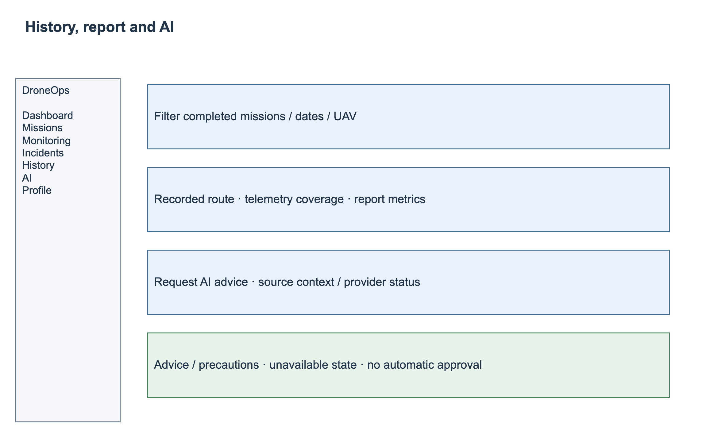
SCR-14 — Screen layout.

3.9.3 Review mission history and post-flight results (UC-18)
Specification | Details
Actors / Interface | Operator; Manager | SCR-13 / SCR-14
Trigger | Mission History > select flight > Report / Incidents.
Preconditions | The user is authenticated and has permission to access the selected mission or record.
Input / Data | Date/status/UAV filters and flight ID.
FR-18.1 — Normal flow | The system shall support the following behavior: List permitted histories; show planned-versus-recorded route where data exists, duration/telemetry summaries, incidents and post-flight report; link incident details.
FR-18.2 — Validation / Alternative flow | Show a scoped empty state when no records match. Label missing or incomplete telemetry and display report coverage. Queued/Generating/Failed/Outdated reports show their status; only Managers may retry or regenerate. This release provides on-screen report viewing; downloadable report export is outside scope.
FR-18.3 — Postcondition | The system shall provide: User reviews recorded flight evidence and report.
Business rules | BR-01; BR-10
Traceability | UC-18
Screen layout — SCR-13
SCR-13 — Screen layout.

3.10 FE-09 — AI-Assisted Mission Decision Support

3.10.1 Request an AI-assisted risk assessment (UC-19)
Specification | Details
Actors / Interface | Operator; Manager | SCR-15
Trigger | Mission Details or Live Monitoring > AI Assessment > Generate.
Preconditions | The user is authenticated and has permission to access the selected mission or record.
Input / Data | Selected current mission or proposed update payload, validation results and available telemetry/incidents.
FR-19.1 — Normal flow | Authorize the mission or pending proposal, capture its context and validation/telemetry availability, and retrieve up to five similar completed flights using normalized route, duration, altitude, vehicle and incident features. Retain source record identifiers and similarity scores. A configured OpenAI or Gemini adapter may summarize the retrieved evidence into mission summary, potential risks and precautions; preserve source links and distinguish observed historical evidence from generated advice.
FR-19.2 — Validation / Alternative flow | Missing essential plan data blocks assessment. No historical matches produces an explicit No historical evidence result, not a zero-risk conclusion. Timeout, rate limiting or invalid provider output shows MSG-11 while preserving retrieved evidence and manual review. Never present generated or fabricated missions as historical evidence. Credentials remain server-side.
FR-19.3 — Postcondition | The system shall provide: Available assessment or explicit failed status; no change to mission approval.
Business rules | BR-11; BR-12
Traceability | UC-19
Screen layout — SCR-15
SCR-15 — Screen layout.

3.10.2 Review AI advice and supplied context (UC-20)
Specification | Details
Actors / Interface | Operator; Manager | SCR-15
Trigger | Open a completed assessment.
Preconditions | The user is authenticated and has permission to access the selected mission or record.
Input / Data | Assessment ID, source mission/update request ID, captured input/time and provider result.
FR-20.1 — Normal flow | Display the assessed mission/proposal, request time, retrieval method, returned historical flights, similarity scores, relevant characteristics and linked incidents alongside summary, potential risks and precautions. Clearly label generated advice and missing evidence. Both roles may request a new assessment; mission edits follow UC-06.
FR-20.2 — Validation / Alternative flow | The system shall enforce the following checks and outcomes: Changed mission/context marks the result outdated; absent data is shown; users cannot overwrite stored provider output and present it as the original result. No model confidence is invented.
FR-20.3 — Postcondition | The system shall provide: Human-reviewed advisory evidence, with manual mission review still available.
Business rules | BR-06; BR-11
Traceability | UC-20

3.11 FE-10 — Mission and Operational Dashboard

3.11.1 View an operational dashboard (UC-21)
Specification | Details
Actors / Interface | Operator; Manager | SCR-02
Trigger | Sign in > Dashboard.
Preconditions | The user is authenticated and has permission to access the selected mission or record.
Input / Data | Authorized scope and date/status/UAV filters.
FR-21.1 — Normal flow | The system shall support the following behavior: Show mission counts/status, active UAV summaries, recent incidents and shortcuts to validation, monitoring, history and AI assessment; drill down to authorized records. Both roles can change view filters.
FR-21.2 — Validation / Alternative flow | The system shall enforce the following checks and outcomes: No data or partial service failure displays scoped empty/unavailable states; never expose inaccessible counts/details. Dashboard metrics do not directly edit mission evidence.
FR-21.3 — Postcondition | The system shall provide: Role-scoped operational overview.
Business rules | BR-01; BR-07
Traceability | UC-21
Screen layout — SCR-02
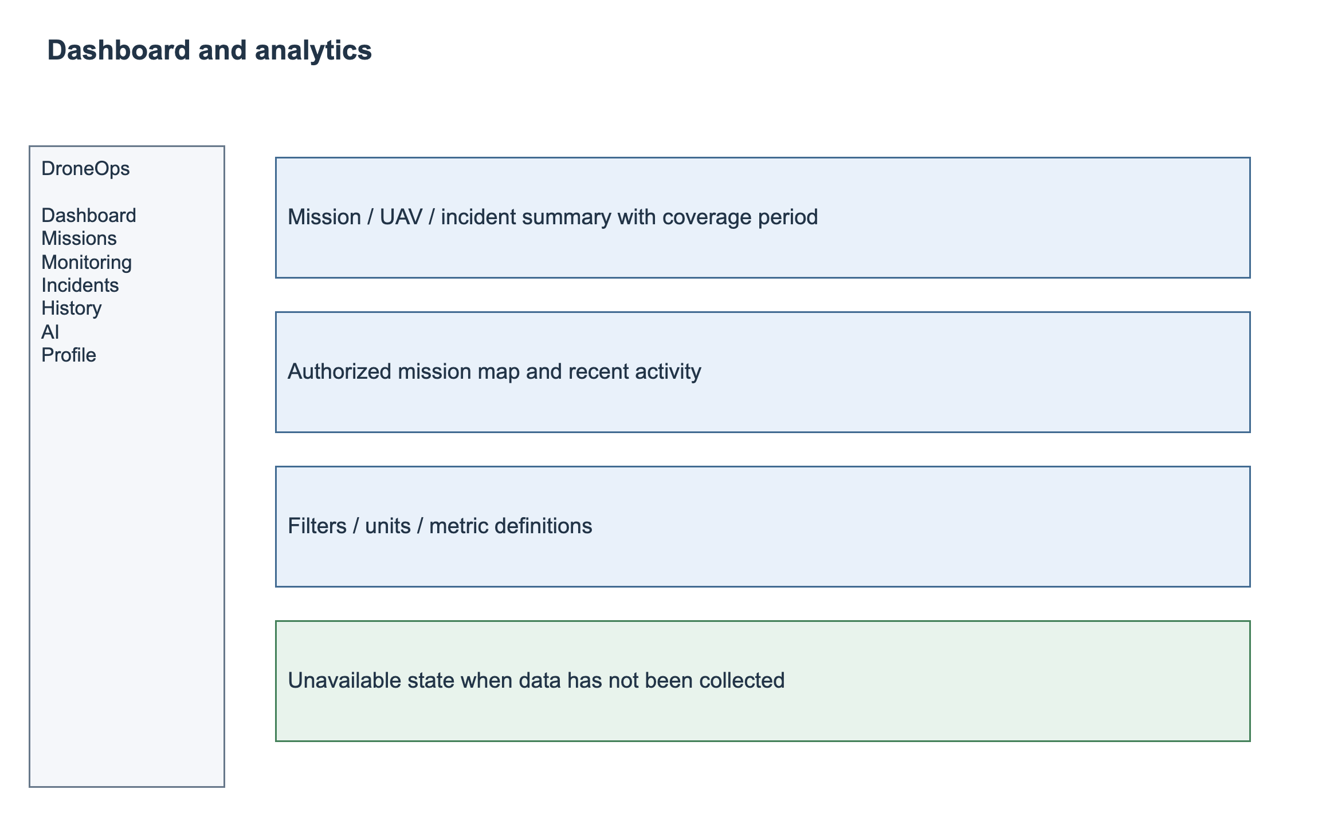
SCR-02 — Screen layout.

3.11.2 Review operational analytics (UC-22)
Specification | Details
Actors / Interface | Operator; Manager | SCR-16
Trigger | Dashboard > Analytics.
Preconditions | The user is authenticated and has permission to access the selected mission or record.
Input / Data | Permitted date range, UAV/mission filters and recorded histories/incidents.
FR-22.1 — Normal flow | Show completion rate, flight duration, recorded distance, incident counts by type/severity and trends within the authorized date/UAV scope. Calculate completion rate as Completed flights divided by all started flights in the selected start-time window, with an empty denominator shown as Unavailable. Duration uses trusted flight start/end timestamps. Recorded distance sums consecutive valid GPS positions and excludes gaps longer than the communication-loss threshold, reporting excluded coverage. Counts use distinct incident IDs, not status events. Display units, window and source links.
FR-22.2 — Validation / Alternative flow | Invalid date ranges shall be rejected. Missing data shall be displayed as unavailable and shall not be interpreted as zero risk.
FR-22.3 — Postcondition | The system shall provide: Explainable aggregate view backed by recorded data.
Business rules | BR-01; BR-10
Traceability | UC-22
Screen layout — SCR-16
SCR-16 — Screen layout.

4. Non-Functional Requirements

4.1 External Interfaces
ID | Interface | Required behavior / Contract boundary
IF-01 | Human Web interface | Web screens shall provide role-scoped navigation, visible validation and status feedback, and explicit units and timestamps. Textual findings shall remain available when the map cannot load.
IF-02 | Operator mobile client | The Operator mobile client supports sign-in/out, own profile, own/assigned mission and validation/decision viewing, live monitoring, alerts and flight history under the same authorization rules. Route authoring and Manager administration are Web-only.
IF-03 | UAV/autopilot or Simulator -> gateway | The configured gateway receives MAVLink 2 telemetry over UDP or TCP and bridges normalized messages to platform services over authenticated WebSocket or MQTT. Retain source/UAV identity, session/sequence, source and received timestamps, units and altitude reference. Enforce configured source mappings; unsupported fields remain unavailable.
IF-04 | Gateway -> platform -> live clients | The telemetry gateway shall normalize and persist messages, preserve source and received timestamps, deduplicate replays and publish authorized live-state updates.
IF-05 | Backend -> external AI provider | Historical-mission retrieval returns scoped source IDs, feature/similarity evidence and related incidents. The optional external AI adapter receives bounded authorized context and returns structured summary, risks and precautions. Provider/model, context limit and timeout are configurable; default request timeout is 30 seconds.
IF-06 | Map/background data | The map interface renders WGS84 route and restriction geometry, supports waypoint/polygon selection and provides attribution required by the selected provider. Provider failure leaves coordinate entry and textual validation available. Restrictions are entered through the polygon editor in this release; external file import is outside scope.
IF-07 | Persistent storage | The system shall retain current missions, update requests, review decisions and linked telemetry, incident, report and assessment evidence.
Performance profile P-01: 5 simulated UAVs at 1 normalized sample/second each; 10 concurrent Web sessions; 100 stored flights with 10,000 samples each; and up to 50 waypoints checked against 20 configured polygons, each containing at most 100 vertices. External map and AI response times are measured separately.

4.2 Quality Attributes

4.2.1 Usability
ID | Requirement | Verification
NFR-U01 | After at most 30 minutes of onboarding, at least 4 of 5 representative testers shall create, validate and submit a prepared 5-waypoint mission within 5 minutes without assistance. | Timed task study.
NFR-U02 | All required-field errors, stale-data states and permission-denied responses shall be understandable without consulting server logs. Core forms shall be usable with keyboard focus and text labels. | Screen walkthrough and keyboard/error-state checks.

4.2.2 Reliability
ID | Requirement | Verification
NFR-R01 | Under P-01, a 60-minute monitoring run shall have no application crash or loss of acknowledged persisted mission/decision/incident records. | Controlled soak test and database/trace evidence.
NFR-R02 | A disconnected stream shall be marked stale/offline within the configured communication-loss threshold plus 2 seconds; restored data shall appear within 5 seconds of accepted reconnect data. | Timed disconnect/reconnect tests using BR-15 thresholds under P-01.
NFR-R03 | AI timeout/provider failure shall not prevent authorized users from opening mission details and performing manual review/decision actions. | Inject provider timeout/rate-limit/invalid response; verify UC-09 remains available.
NFR-R04 | A failed report-generation attempt shall preserve flight evidence, expose Failed status and allow scoped Manager retry for completed flights. | Inject generation failure, retry and late-data regeneration; verify retained revisions.

4.2.3 Performance
ID | Requirement | Verification
NFR-P01 | Under P-01, 95% of normal list/detail requests shall complete within 2 seconds, excluding external map/AI latency. | Measure at least 100 requests after warm-up; document hardware/network.
NFR-P02 | Under P-01, 95% of accepted telemetry samples shall reach the authorized live view within 2 seconds of gateway receipt. | Correlate gateway-received and client-rendered timestamps with synchronized clocks.
NFR-P03 | Under the P-01 route/restriction limits, 95% of pre-flight validations shall finish within 3 seconds. | At least 30 controlled valid/invalid route cases.
NFR-P04 | The AI request timeout shall be configurable. When it expires, the application shall leave the loading state and provide retry and manual-review options. | Delayed-provider response test with application timeout verification.

4.2.4 Security and Privacy
ID | Requirement | Verification
NFR-S01 | Every protected screen operation and corresponding API shall reject unauthorized role or out-of-scope record access, including direct identifier requests. | Positive/negative matrix tests for section 3.1.3.
NFR-S02 | Passwords shall be stored as secure hashes. Provider credentials shall remain on the server. Authentication and application data shall use encrypted transport. | Configuration/code review and response/log inspection.
NFR-S03 | AI requests shall include only authorized relevant mission context and shall exclude credentials and unnecessary account identifiers. | Inspect authorized request payloads and configured retention policies.
NFR-S04 | License images shall be private and accessible only to the owner and authorized reviewers through expiring access. Reject unsupported image types or files above 5 MB. Do not persist credentials, OTP values or private object access tokens in application logs. | Cross-account access tests, expired-link checks and upload validation.
NFR-S05 | Retain mission decisions, execution evidence, telemetry, incidents and reports for 12 months after flight completion. Retain superseded/rejected license images for 90 days after the decision; retain the current image while the account is active. Authorized retention jobs remove expired data without leaving broken active references and audit the deletion. | Time-controlled retention tests including dependent-record and media cleanup.

4.2.5 Maintainability and Testability
ID | Requirement | Verification
NFR-M01 | FE/UC/FR identifiers shall map to implementation and test cases for release acceptance. Core rules, timers, retrieval and external adapters shall support deterministic fixtures. | Traceability review and repeatable fixture-based test runs.
NFR-M02 | Evaluate historical retrieval on a fixed labeled mission set with documented relevance criteria, feature configuration and k=5. Report Precision@5, returned evidence links and query latency; manually assess fewer-than-five and no-match cases. | Retain labeled queries, expected relevant records and reproducible measured results.

4.2.6 Compatibility and Recovery
ID | Requirement | Verification
NFR-C01 | The Web application shall support Chrome and Edge at desktop viewport widths of 1280 and 1440 pixels. | Record exact tested versions at release; responsive screen review.
NFR-C02 | The system shall support scheduled backups and restoration of persisted records and linked private media according to NFR-C03. | Backup/restore rehearsal.
NFR-C03 | Daily backups shall cover mission, review, account/license metadata, telemetry and incident records. Recovery point objective is 24 hours and recovery time objective is 4 hours for the reference deployment. Storage-object recovery shall be included in the rehearsal. | Restore a backup and linked media in an isolated environment; measure data gap and elapsed time.

5. Requirement Appendix

5.1 Business Rules
ID | Rule Definition
BR-01 | Every human request is authenticated and authorized for the action and record scope; external telemetry/AI integrations use configured integration credentials, not human login.
BR-02 | UAVs and pilots must be active and eligible. A pilot license must be approved, unrevoked and valid through the scheduled flight end. Deactivation preserves history and is blocked for an active flight. Assignment conflicts follow BR-14.
BR-03 | Approval applies only to the reviewed mission or proposed update after mandatory spatial checks pass with current evidence. Applying a proposal updates the same mission atomically. Incomplete/error/stale validation cannot authorize approval.
BR-04 | Both waypoints and connecting route segments shall be validated against active restrictions using their configured coordinate units, altitude reference and boundary rules.
BR-05 | Initial mission submission and every later pre-flight edit require Manager review. Initial Draft creation is not submission. No application action issues low-level flight-control commands. Lifecycle rules follow BR-13.
BR-06 | Mission changes, validation runs and decisions link to mission ID and update request ID. Every accepted edit requires Manager review. Approved current content and status remain unchanged until a proposal is approved; rejected proposals never overwrite them. Earlier evidence cannot authorize changed content.
BR-07 | Telemetry and displayed summaries retain source/received timestamps and missing-data indicators. Unknown or stale measurements must not appear as fresh valid data.
BR-08 | Communication loss shall be evaluated by an independent timer as well as on packet arrival. Timeout and recovery conditions shall be configurable.
BR-09 | Incidents shall retain type, time, UAV/mission association and frozen event evidence. Acknowledgement and resolution shall record actor, timestamp and reason without rewriting source telemetry.
BR-10 | Post-flight reports and analytics shall use stored mission, telemetry and incident evidence and show missing data and coverage explicitly. Calculated metrics shall retain their units and covered time window.
BR-11 | AI output provides mission summaries, risk observations and precautions for human review. It does not approve/reject a mission or command a UAV. API failure must not block manual review.
BR-12 | Record actor/integration identity, action, target and timestamp for material changes; protect credentials and restrict source context sent to AI to permitted mission data.
BR-13 | Mission lifecycle: Draft -> Pending Review -> Approved or Rejected. Draft/Rejected may be initially submitted; each accepted edit to a non-executing mission creates a pending update without changing current content/status. Update approval applies content and sets Approved; update rejection preserves current content/status. A newer accepted proposal supersedes the previous pending review. Draft/Pending Review/Rejected/Approved may be cancelled; executing or terminal missions cannot be edited. Flight start requires Approved, fresh validation, eligible assignments and no pending update. A trusted start event creates one flight and moves the mission to In Progress; a trusted completion event moves it to Completed. Reflight requires a new mission.
BR-14 | Schedules use UTC instants and display the user time zone. End must exceed start. Approved missions reserve UAV/pilot intervals [start,end); adjacent intervals do not conflict. Pending submissions/proposals are checked again atomically at approval and flight start. A proposal cannot reserve over another approved booking; its existing approved reservation is replaced only on approval.
BR-15 | Default detector settings: communication loss after 10 seconds without a valid mapped sample, checked at least once per second; recovery requires two consecutive valid samples. Battery below 20% for two consecutive samples is Warning; recovery requires two samples at or above 25%. Altitude outside the approved/configured MSL range and speed above the configured UAV maximum for two consecutive samples are Critical; recovery requires two samples within limits. Communication loss is Critical. Missing thresholds or altitude conversion disable the affected rule with visible diagnostics. Manager-configured changes are audited; severity escalations update the same incident with retained evidence.
BR-16 | The author cannot approve their own proposed mission update or license-change request. Another authorized Manager must review it. No mission may start with a pending proposal; no flight-control action is issued to enforce this planning decision.
BR-17 | Keep current account email and approved license until replacement verification/review succeeds. A rejected or cancelled license request does not modify current credentials. Expiry of the current license still affects eligibility while a replacement is pending.
BR-18 | Historical similarity retrieval uses up to five completed flights in the authorized data scope. Normalize numeric features with a recorded feature schema and score method; display fewer than five when fewer eligible records exist. Store feature/index configuration and evidence IDs with each assessment. AI provider output cannot change approval or detector thresholds.

5.2 Common Requirements
ID | Requirement
CR-01 | Enforce authentication/action/record authorization at the backend; session expiry returns the user to sign-in without treating an unsaved change as persisted.
CR-02 | Validate required fields, ranges and unique identifiers on the server and provide field-level feedback. Do not rely solely on client validation.
CR-03 | Persist timestamps in UTC and display them with an explicit user-zone label; default display zone is Asia/Ho_Chi_Minh. Display metres MSL for planned altitude, m/s for speed, metres/kilometres for distance and percent for battery. Preserve incoming altitude reference; unavailable conversion is explicit.
CR-04 | Search/filter/pagination must preserve permitted scope and show explicit loading, empty, error and stale states; default page size is a UI decision.
CR-05 | Prevent silent concurrent overwrite using request identity, a current-payload fingerprint and an atomic pending-request pointer, without mission versioning. Only the current pending request may be decided. A stale form returns a conflict; retry of the same operation does not duplicate a review, decision, flight, alert or incident. Preserve the approved execution snapshot independently of later source changes.
CR-06 | Confirm destructive/deactivation/cancellation actions; preserve history required by references and retention policy. No user-facing Cancel action issues a UAV stop command.
CR-07 | Changes and material automated outcomes retain actor/source, target, time and result evidence; do not expose credentials in errors or audit output.
CR-08 | Use consistent English application messages; escape substituted values before display. Show field-level failures and prominent success/error feedback with keyboard-accessible status text. Changing presentation language does not alter persisted evidence.

5.3 Application Messages List
Code | Type | Context | Content
MSG-01 | Inline | Required/invalid field | Enter a valid {field}.
MSG-02 | Inline | Invalid login | Unable to sign in. Check your credentials.
MSG-03 | Page / toast | Access denied | You do not have permission to perform this action.
MSG-04 | Toast | Save succeeds | Changes saved successfully.
MSG-05 | Dialog | Concurrent update | This record has changed. Reload before saving.
MSG-06 | Banner | Mandatory validation failure | Mission validation failed. Review the highlighted violations.
MSG-07 | Banner | Validation incomplete | Validation is unavailable or incomplete. Approval is blocked.
MSG-08 | Toast | Submitted | Mission submitted for review.
MSG-09 | Banner | Stale telemetry | Telemetry is stale. Last update: {timestamp}.
MSG-10 | In-app alert | Incident raised | {incidentType} detected for {uavName}. Open incident details.
MSG-11 | Banner | AI unavailable | AI assessment is unavailable. Retry later or continue manual review.
MSG-12 | Banner | Outdated assessment | Mission data has changed since this assessment. Generate a new assessment.
MSG-13 | Empty state | No matching data | No matching records found.
MSG-14 | Report status | Generation failed | The report could not be generated. Flight data is preserved.
MSG-15 | Confirmation | Cancel plan | Cancel this mission plan? This does not stop or control a UAV.
MSG-16 | Inline | Rejection reason absent | Enter a reason for rejecting this mission.
MSG-17 | Banner | Map unavailable | The map is unavailable. Review the listed coordinates and validation results.
MSG-18 | Banner | Session expired | Your session has expired. Sign in again.
MSG-19 | Inline / banner | Email already registered | This email is already registered. Enter another email.
MSG-20 | Success banner | Verification sent | A verification code was sent to {email}. Check your inbox.
MSG-21 | Inline | Invalid or expired code | The verification code is invalid or expired. Request a new code.
MSG-22 | Success banner | Email changed | Your email has been changed. Sign in again.
MSG-23 | Banner | License request submitted | Your license change is awaiting review. Your current license remains unchanged.
MSG-24 | Banner | License decision | Your license change was {decision}. {reason}
MSG-25 | Banner | Pending mission update | An update is awaiting review. This mission cannot start until review is complete.
MSG-26 | Banner | No historical evidence | No similar historical flights are available. Continue manual review.
MSG-27 | Inline | Verification rate limit | Please wait {seconds} seconds before requesting another code.

5.4 Requirements Traceability
Feature | Use Cases | Detailed FRs | Screens / Non-screen
FE-01 | UC-01–UC-04; UC-23–UC-26 | FR-01.1–FR-04.3; FR-23.1–FR-26.3 | SCR-01; SCR-03–SCR-05; SCR-17–SCR-21; NSF-09/10
FE-02 | UC-05, UC-06, UC-07 | FR-05.1-.3; FR-06.1-.3; FR-07.1-.3 | SCR-07; SCR-06 / SCR-08
FE-03 | UC-08, UC-09, UC-10 | FR-08.1-.3; FR-09.1-.3; FR-10.1-.3 | SCR-08; SCR-09
FE-04 | UC-11, UC-12 | FR-11.1-.3; FR-12.1-.3 | SCR-08 / background; SCR-08
FE-05 | UC-13 | FR-13.1-.3 | Non-screen
FE-06 | UC-14 | FR-14.1-.3 | SCR-10
FE-07 | UC-15 | FR-15.1-.3 | SCR-10 / SCR-11 / background
FE-08 | UC-16, UC-17, UC-18 | FR-16.1-.3; FR-17.1-.3; FR-18.1-.3 | SCR-11 / SCR-12; SCR-14 / background; SCR-13 / SCR-14
FE-09 | UC-19, UC-20 | FR-19.1-.3; FR-20.1-.3 | SCR-15; NSF-07/11
FE-10 | UC-21, UC-22 | FR-21.1-.3; FR-22.1-.3 | SCR-02; SCR-16

5.5 Terms and Data Conventions
Mission: the current planning record with one stable ID. Mission update request: a separately stored proposed change requiring review, not an executable mission or mission version. Flight: the immutable execution record created from an approved mission at start.
MSL: altitude above mean sea level. AGL: altitude above local ground; conversion requires terrain/reference data. WGS84: geographic coordinate reference for latitude and longitude.
Fresh telemetry: valid mapped data received within the configured communication-loss threshold. Stale/offline: the threshold has elapsed; last-known values remain visible with timestamps. An incident episode persists until measured recovery.
Top-k retrieval: selecting up to k relevant completed flights using a recorded feature representation and similarity method. Similarity is not a calibrated probability of safety or incident occurrence.

